**The Private Returns to Knowledge: A Comparison of ICT, Biotechnologies, Nanotechnologies, and Green Technologies**

Draft version. Final version forthcoming in *Technological Forecasting & Social Change*

**Tobias Stucki**

Bern University of Applied Sciences

tobias.stucki@bfh.ch

**Martin Woerter**

ETH Zuerich, Switzerland

[woerter@kof.ethz.ch](mailto:woerter@kof.ethz.ch)

**Abstract:** ICT, biotechnologies, nanotechnologies, and green technologies are among the most important emerging technological activities and may substantially increase economic returns. However, empirical evidence is rather scarce, as most existing literature focuses on the economic returns to knowledge in general and does not compare the effects of knowledge in different types of technologies. Based on a well-founded productivity model, we find (a) that knowledge in these “new growth” technologies shows larger economic returns than knowledge in traditional technologies; (b) a solid knowledge stock in traditional technologies is required to achieve positive economic returns from “new growth” technologies; (c) there are significant differences in the economic returns; the largest effects are achieved through knowledge in ICT, followed by biotechnology. Only moderate economic returns are detected for knowledge in nanotechnologies, and green technologies; (d) we also identify some evidence that technology convergence, i.e. technologies that are based on inter-disciplinary research activities, show larger economic returns than technologies generated based on a single discipline.

JEL.: O30

Keywords: technology comparisons; productivity; innovation; patents; biotechnology; nanotechnology; green technology; information- and communication technology;

**Acknowledgement:** The authors acknowledge financial support from the MTEC-Foundation.

Introduction

The aim of this paper is to determine the economic returns of "new growth" technologies. Unlike most studies in this field of research (Van Reenen et al. 2010, Gordon 2015, Stucki 2019), our paper deals with the generation and not the use of these new growth technologies. In our setting new growth technology includes information and communication technology (ICT), biotechnology, nanotechnology, and green technology. These technologies are expected to increase productivity, as they propose new solutions to problems widespread in social and economic processes (Gokhberg et al. 2013), they act as enabler of innovation throughout the economy (OECD 2015, Brynjolfsson and McAfee 2014, Ebers and Powell 2007), they (partly) contribute to technology convergence (Mangematin and Walsh 2012), or, especially in the case of green technologies, they address very important problems of our time (Gokhberg et al. 2013, IPCC 2014). Despite their large potentials, it is mostly unclear whether knowledge in these technologies already translates into positive productivity contributions.

Information about the economic returns to knowledge in these technological fields is of central importance to understand the pace of technological progress and the direction and biases of endogenous technological change (Acemoglu 2002, Aghion and Howitt 1990). Schumpeter (1942) already identified profit orientation as an essential factor for technological progress. He said that “the direction of innovation activities depends upon the prizes offered by the capitalistic society to the successful inventor” (Schumpeter 1942, p. 102). Profitable technological activities do not only mark the pace and direction of innovation efforts, they also help us to identify technological fields with currently low incentives for knowledge investments and–if it is in the interest of the society–to identify market failures and the need for policy action when profitability is lacking.

Existing broader empirical investigations on the economic returns to knowledge mainly focus on the returns to R&D activities in general (Hall et al. 2010 for an overview) and do neither directly compare the economic returns to knowledge in different types of (new growth) technologies nor do they look at important aspects like technology convergence or competence effects of new growth technologies (see Section 2 for a review of the literature).

In this paper, we give a comprehensive overview of the economic returns to knowledge in these “new growth” technologies by investigating three important topics. First, we analyze the economic returns to knowledge in these technologies simultaneously which allows us to compare their effects. Second, we investigate how traditional knowledge moderates the economic returns to knowledge in new growth technologies. In this way, we can see whether knowledge of new growth technologies destroys or strengthens competences (Tushman and Anderson 1986). Third, we also analyze the economic returns of technology convergence, focusing on convergence with green technologies. Convergence usually occurs when key technologies are combined with other technologies promising new or added value beyond synergies (OECD 2013).

As a starting point we build our paper on Eberhardt et al. (2013). We use their data as well as methodology to estimate a well-founded Cobb-Douglas production function. To be able to investigate the different aspects of knowledge returns, we supplement their data set with patent data that we collected specifically for this analysis. While Eberhardt et al. (2013) focuses on general knowledge, the collected patent data allows us to construct separate measures for the knowledge in ICT, nanotechnology, biotechnology, and green technology. We focus on the industry level, which includes start-ups and micro firms that are often the creators of the new technologies; they are usually excluded in more disaggregated data sets. It also allows us to consider the most important countries in terms of innovation activity and a long period of time. Finally, by excluding the effect of knowledge spillovers, we identify the private returns to knowledge. Hence, we take the perspective of a manager who cannot affect spillovers from other actors, but is primarily interested in the returns to its own investments; windfall gains from knowledge activities of other firms are appreciated, but managers cannot count on them.

The main results are: first, knowledge in new growth technologies (in sum) shows a significant and positive impact on productivity growth. Second, knowledge in ICT shows the greatest effects on productivity followed by biotechnology, green technologies, and nanotechnologies, whereas the differences between green technologies and nanotechnologies are not significant. Third, knowledge in traditional technologies shows a positive effect on productivity in combination with knowledge in new growth technologies. This points at the competence-enhancing effect of new-growth technologies or the complementarity between traditional and new-growth knowledge. Fourth, we provide first empirical evidence of positive productivity effects of technology convergence.

The reminder of this paper is organized as follows. Section 2 lays out the theoretical and empirical background. Section 3 presents the data and describes the empirical framework for data analyses. Section 4 shows the result and provides some robustness test. The conclusions and limitations of the study are presented in Section 5.

Background

Scholars comprehensively investigated the economic returns to knowledge based on R&D activities (see Crepon et al. 1998 or Hall et al. 2010 for a comprehensive overview). This literature can largely confirm the significant positive relationship between investments in the generation of new technologies and economic returns. Hall et al. (2013) found a positive correlation between the citation-weighted patent stock and Tobin’s-Q. Arora et al. (2008) found that the returns to patented inventions are sector specific and Falk (2007)–at the country level–found positive returns to R&D only in the high-tech sector. Based on a sophisticated dynamic, structural model, Peters et al. (2017) identified positive R&D effects on firm value in Germany; larger effects are found for high-tech industries than for low-tech industries. Ortega-Argilès et al. (2010) examined the top 532 European R&D investors and found that the productivity effects in the high-tech sectors are significantly higher than in low – and medium-tech sector. This suggests that countries with a strong high-tech sector benefit more from first-mover advantages in new technology development and the productivity gap between regions or countries with technological activities could increase (Ortega-Argilès et al. 2014, 2015). Eberhardt et al. (2013) found at best moderate productivity effects of R&D in controlling for different types of spillovers at the industry level. This is in line with the above results, considering that a specific sectoral composition and technological relatedness, e.g. strong high-tech sector, leads to larger spillovers that significantly increase the returns to R&D activities (Howell et al. 2016). The focus of all these studies, however, was on the general economic returns to knowledge, taking into account a certain heterogeneity at sector level. Our knowledge about the economic returns to knowledge in specific technological fields is meager.

*The effects of ICT, biotechnology, nanotechnology, and green technology on productivity*

The focus of this paper is on new growth technology, which includes information and communication technology (ICT), biotechnology, nanotechnology, and green technology. The choice of technologies is driven by several factors: a) we want to investigate emerging technologies as they are defined in Gokhberg et al. (2013); they comprise besides converging technologies like ICT, biotech and nanotech also problem oriented technologies like green technologies; b) all these technologies have been heavily discussed in the literature (see Ebers and Powell 2007, Mangematin and Walsh 2012, Rothaermel and Thursby 2007 and the extensive literature on green innovation such as Aghion et al. 2016, Ley et al. 2016, Soltmann et al. 2015, Stucki and Woerter 2017); c) the choice is also driven by convenience, since there has been considerable effort by international organizations (OECD, WIPO) to find a clear, patent classification-based, definition for these technologies, which we can apply (see Appendix 1).

Studies dealing with ICT and productivity mostly focused on the performance effects of the *use* rather than the *generation* of ICT (see Van Reenen et al. 2010, Syverson 2011, Biagi 2013, Gordon 2015, Venturini, 2015, Stucki and Wochner 2018). More related to what we do, Van Ark et al. (2003) identified ICT-generating industries in Canada, Europe, and the United States and looked at their overall productivity contribution. They separated the ICT-generating sector from the ICT-using sector and found that the productivity growth in the ICT-generating sector was higher than in nearly all other sectors. Similar, Pilat et al. (2002) found a positive contribution of the ICT-producing sector on a country’s overall labor productivity growth; the productivity contribution has increased over the 1990s. However, in contrast to our study, this literature does not investigate the drivers of these productivity effects and it remains unclear whether they come from ICT-specific knowledge.

Most of the empirical investigations in the field of biotechnology look at the returns to R&D investments on *innovation outcome*, for instance, in terms of patents (OECD 2006), the probability that a firm completes a development stage (Danzon et al. 2005), or they look at the number of drugs approved (Pammolli et al. 2011). The *economic* returns to knowledge in biotechnology has not been analyzed based on a broad empirical basis.

Despite considerable private and public efforts to foster the development of nanotechnologies, there are still few studies that examine the economic returns of such activities. Walsh et al. (2010) discussed potential drivers of the economic value of nanotechnologies based on several case studies.[1] In contrast to their study, we identify the economic returns to knowledge in nanotechnologies empirically. Hence, we do not rely on specific information on the economic value of a certain technology, which allows us to be much broader in our analysis.

In the field of green technologies, too, there are only a few empirical studies that investigate the economic returns to knowledge on a broad basis.[2] Soltmann et al. (2015) investigated the effects of green patent activities on the performance of an industry; their results indicate a negative impact. A related finding was reported by Marin (2014), who found that green innovations tend to crowd out more profitable non-green innovations, which suggests that firms switching to green innovations tend to be less profitable.

*Concurrent generation of knowledge: new growth technologies and traditional technologies*

We characterize the new technologies in terms of “competence-enhancing” or “competence-destroying”, which is a research question that has been heavily discussed in the literature on new technologies. Schumpeter (1942) argued that new technologies create new market opportunities while *destroying* or damaging existing demand (creative destruction). On the one hand, the process of knowledge generation in new technologies can be interpreted as competence-destroying, since primarily generic new knowledge is expected to be necessary to be competitive in developing new technologies. On the other hand, several studies also consider the opportunity that new technologies can *enhance* the existing competences of a firm as they build on available skills, abilities, and knowledge both in the development and manufacture of the product (Tushman and Anderson 1986).

With respect to new growth technologies, it is thus not a priori clear, whether existing competences correspond to generic new capabilities (competence-enhancing), or whether there is a negative relationship (competence-destroying). We will investigate this topic by identifying the economic returns to the concurrent generation of knowledge in traditional and new growth technologies, whereby a negative effect would indicate a competence-destroying and a positive effect a competence-enhancing relationship.

The economic returns to the concurrent generation of knowledge in traditional and new growth technologies have not been analyzed so far. Most related to this topic is probably the study by Rothaermel and Hill (2005). The authors analyzed the existence of structural breaks in productivity growth in the steel, computer, pharmaceutical and telecommunications industries in the USA. They observed that the structural breaks lead to a negative structural shift in the performance of the computer industry and the steel industry, and a positive shift in the performance of the pharmaceutical industry and the telecommunications industry. By interpreting the structural breaks as technology discontinuities, these results allow some conclusions about how technological discontinuities affect the performance in different industries.[3]

Moreover, by using an unbalanced panel of Dutch firm level data, Van Leeuwen and Mohnen (2017) investigated the relationship between labor productivity and two types of green innovations; these are pollution-reducing innovation and resource-saving innovation. Their results are inconclusive, since the effect depends on the type of innovation. While pollution-reducing green innovation are negatively related with labor productivity, resource-saving innovation increase labor productivity.

Finally, there are also some studies that analyzed how knowledge affects innovation performance rather than economic performance.[4] In order to influence economic performance, however, not only complementarities in R&D are relevant, but also complementarities at the commercial level that relate to existing organizational capabilities in downstream functions (Pisano 1990, Rothaermel and Hill 2005). Hence, we cannot conclude from a positive correlation between traditional and new knowledge that there are complementarities with respect to economic performance.

*Convergence of new growth technologies*

Convergence arises when scientific disciplines or key technologies are combined with other disciplines or technologies and promise new or additional values beyond synergies (OECD 2013). The Massachusetts Institute of Technology (MIT) for example identified the convergence of the life sciences, physical sciences, and engineering as an important new research model (MIT 2011). Rapid advances in convergent technologies are expected to have the potential to enhance both human performance and the nation’s productivity (Roco and Bainbridge 2003).

In this paper, we focus on technology convergence with green technologies. During the last years, expectations have risen that technology convergence allows progress on environmental performance. Especially the convergence of biotechnology (OECD 2009), nanotechnology (OECD 2013; Shapira and Youtie 2015) and ICT (Reimsbach-Kounatze 2009) with green technology is expected to provide technological solutions to global environmental problems. However, it is unclear whether expectations are already reflected in positive productivity contributions from technological convergence with green technologies.

Existing studies that analyze the convergence of new growth technologies primarily focus on the characterization of the convergence process based on case studies or specific technologies (see OECD 2013, 2014). To the best of our knowledge, the productivity effects of technology convergence have not been analyzed so far.

Data and methods

*Baseline productivity model*

In order to identify the productivity effect of knowledge in new growth technologies, we estimate an augmented Cobb-Douglas production function in the spirit of Griliches (1979), whereat value added *Y* is driven by labor *L*, physical capital *K* and knowledge capital *R*:

$Y=F\left(L,K,R\right).$ (1)

As discussed before, the productivity effect of knowledge capital in general has been analyzed in several studies before, but what is missing so far is the analysis of the relative productivity effects of knowledge in new growth technologies and traditional technologies. We make use of a well-established modelling framework and data set introduced by Eberhardt et al. (2013); this data set allows us to measure the standard factors of the Cobb-Douglas production function *Y*, *L*, and *K*.

Cobb-Douglas production functions serve as a workhorse for empirical research in the field of innovation economics at the latest since the seminal work of Griliches (1980). This conceptual framework has been frequently used and it is deemed to be a standard approach in investigating the relationship between knowledge and economic performance (see Hall et al. 2010). However, the standard form does hardly pay attention to knowledge spillovers. They are usually treated like unobserved heterogeneity presumably uncorrelated with the observed knowledge effect.

However, considering such knowledge spillovers is of great importance in our setting, as the investigated technologies are in very different development stages and the respective amount of knowledge accumulation is very different as well. Whereas nanotechnology is a relatively young technology, ICT or Biotechnology are older technologies with a greater amount of accumulated knowledge. Since the amount of spillovers is immediately related to the size of the knowledge stock (see Stucki and Woerter 2017), the observed coefficient for the knowledge stock variables cannot be seen as independent from the unobserved heterogeneity related to spillovers. Moreover, the application potential of the investigated technologies is different. ICT, for instance, is a general-purpose technology, which might create spillovers for the development of many types of technologies, which are based on traditional knowledge. Green technologies do not have such far-reaching influence; hence, also their spillover potential is different and need to be considered.

There are two different ways to deal with such knowledge spillovers. Either by generating a spillover variable that allows to directly identify the effect of the spillovers (see, e.g., Añón-Higón 2007 for such an approach). Or, by excluding the spillover effects and focusing on the private returns to knowledge (see Eberhardt et al. 2013). Due to the large number of different knowledge stocks in our setting, we would need to consider spillovers for all different technologies, which is not applicable in practice.[5] Hence, we choose the later approach. By focusing on private returns, we take the perspective of a manager, who cannot affect spillovers from other actors, but is primarily interested in the returns to its own investments; windfall gains from the knowledge activities of other firms are appreciated, but managers cannot count on them.

In what follows, the data and modelling strategy are discussed in detail.

*Data*

The data set introduced by Eberhardt et al. (2013) comprises information on twelve manufacturing industries[6] in ten OECD countries (Denmark, Finland, Germany, Italy, Japan, the Netherlands, Portugal, Sweden, United Kingdom, and the United States)[7] over a period of 26 years from 1980 to 2005.[8] Hence, our analysis is restricted to the manufacturing sector. This makes sense, as the considered technologies may be used in the service sector, but are generated in the manufacturing sector. Based on information from the EU KLEMS data set for the production data, and Eurostat and the OECD for GDP deflators, they constructed appropriate measures for value added, labor and capital stock (see online appendix of Eberhardt et al. 2013 for detailed information on data construction).[9]

Based on the EU KLEMS data set and the OECD ANBERD data they also constructed R&D stocks to measure knowledge capital. However, in this paper we are not interested in the effect of general knowledge capital but in the relative effect of knowledge in new growth technologies. Unfortunately, no comparable R&D data is available for the different new growth technologies for multiple countries and over a long time-period. Hence, scholars in this field of research have turned to use patent data (Bresnahan 2010). Although patent statistics have many disadvantages in measuring knowledge capital as many patents are associated with little innovation, and important innovations may not be captured by patents (Hall and Trajtenberg 2004), patent data remains a unique resource for the measurement of knowledge capital in different technology fields as it is readily available and comparable across countries (Hall et al. 2010; Johnstone et al. 2010). This is especially true for the new growth technologies considered in this paper, since the OECD provides definitions of all these technologies based on the patent classification. To empirically test whether our measures are appropriate proxies for knowledge capital, we will also calculate a measure for the industries’ total knowledge capital, which allows us to compare our results directly with the findings of Eberhardt et al. (2013) based on R&D data.

In order to construct measures for the industries’ knowledge capital in the different technology fields that can be matched to the other measures of the productivity model, we add to the data set of Eberhardt et al. (2013) patent data at the same industry classification level, for the same countries and the same time period. Patent documents considered as covering green technology, ICT, biotechnology and nanotechnology inventions, respectively, are identified according to the respective OECD and WIPO classifications (OECD 2008; OECD 2011; WIPO 2013), which are based on the international patent classification (IPC; see Appendix 1 for more information). To collect the patent data, further specifications and clarifications had to be made:

To assign patents to countries, the applicant’s country of residence or the inventor’s country of residence may be chosen. We assigned patents according to the inventor’s address.[10] The main reason is that we want to mirror the innovation activities within industry/country. This way we try to avoid that the assignment of patents is unduly distorted by strategic application decisions of the management in larger, multinational companies. For instance, large pharmaceutical companies can decide that the Swiss headquarter applies for the patent due to tax reasons, although the patent has been invented in England.

We collected inventions (patent families) rather than single patents. The patent data stem from the EPO (European Patent Offices) World Patent Statistical database (PATSTAT). Patents were grouped into patent families according to the PATSTAT procedure (INPADOC). This approach mitigates distortions caused by different national granting procedures and different application attitudes (USA for example has greater number of single applications for one invention compared to Europe).

We use patent applications – as it is usually done in the literature (see Hottenrott et al. 2017, de Rassenfosse 2013). The main reason is that it can take on average more than four years to get a patent granted (see Harhoff and Wagner 2009). Since we use patent applications as a proxy for R&D expenditures/capital and these expenditures occurred independently of the fact whether the patents is granted or not, we think that this is the right unit of analysis in this case.

In addition to the number of inventions, we also collected information on the respective forward citations to calculate citation-weighted patent stocks that are expected to better proxy the market value of knowledge than simple patent stocks (Hall et al. 2005, Nagaoka et al. 2010). The number of forward citations typically reflects the technological quality of patents, which should be highly correlated with commercial quality. Forward citations within a window of five years are considered, which is usually done in the literature (see Lanjouw and Schankerman 2004).

Most of our model variables are classified by industrial sectors and not according to technology classes. Schmoch et al. (2003) developed a concordance scheme that links IPC information included in the patent statistics to industries.[11] Based on this concordance table, we assigned all patents to industries, and finally we recoded our invention data into 12 manufacturing industry classes.[12]

*Descriptive statistics*

In sum, the ten countries considered in this study account for about 80% of all patents worldwide (for some of the new growth technologies they account for up to 84% of all patents worldwide). Hence, our findings are likely to be representative of the overall patenting activities.

Not surprisingly, the patenting activities increased in all considered technology fields over time (see Figures 1a and 1b); however, we observe substantial differences in the growth rates. While the share of traditional technologies in total patents declined continuously over time, primarily the share of ICT inventions increased. In 2005, about 106,000 ICT inventions were patented, which represents 35% of all inventions at this point in time. Moderate growth rates are observed for green and biotech inventions. The share of green inventions in total inventions remained almost constant at 4%, the share of biotech inventions in total inventions slightly increased from 1% in 1980 to 4% in 2005. Compared with the other new growth technologies, few inventions were classified as nanotechnologies. In 2005, we count 1,176 patented inventions in nanotechnology; these are only 0.4% of all patented inventions.

When we have a look at the citation-weighted patents, the picture is almost the same (see Figures 1c and 1d). The only exception is that ICT inventions received more forward citations on average than inventions in the other technology fields. Since 1995, total citations of ICT even exceeds total citations of traditional technologies. In 2005, nearly half of all forward citations refer to ICT.

The relative importance of the different technologies is largely the same at the country level (see Table 1a). Nevertheless, interesting differences exist. Germany, Denmark and Portugal show a high degree of specialization in green invention activities. Denmark and Portugal also show a high specialization in biotechnologies. Japan, Finland, the Netherlands and the United States are highly specialized in the development of ICT. In all countries, few patents refer to nanotechnologies.

While all twelve manufacturing industries created green technologies, ICTs, biotechnologies, and nanotechnologies were patented only in selected industries (see Table 1b). This can be (partly) related to the assignment of patent classes to industries and in the construction of the applied definitions (OECD, WIPO). The applied concordance table (Schmoch et al. 2003) assigns a patent class to the industry that predominately patent in this field. Hence, minor patent activities in the respective technological class from the firms of other industries are neglected. The ‘chemical’ and ‘electrical equipment’ industries registered biotechnology patents. Nanotechnologies were developed only in the two industries ‘electrical equipment’ and ‘metals’. ICT patents were found exclusively in the ‘electrical equipment’ industry. These descriptive facts show that potential productivity effects of these technologies are due to selected industries, which must be considered in the discussion of the results. One should note that we cannot simply exclude from our sample industries that do not generate a specific technology, such as biotechnology in the transport and steel industries. Such industries are an important part of the identification process, since they allow us to detect, whether any differences in productivity can be effectively attributed to a specific technology, or whether they can also be observed in industries that do not generate such technologies. The inclusion of these industries is therefore important. If we simply exclude certain industries from our analysis, we would even risk selection issues.

*Econometric procedure*

As knowledge takes time to translate into innovation, both past and current knowledge matter for productivity. Hence, it does not make sense to merely use current patent flows to proxy knowledge capital. Following Cockburn and Griliches (1988), we use the perpetual inventory method to calculate the stock of patents, i.e. the patent stock for an industry *j*, in country *i* at time *t* is defined as

|  |  |
| --- | --- |
| $${Patent_stock}_{ijt}=\left(1-δ\right){Patent_{stock}}_{ijt-1}+{Patents}_{ijt},$$ | (2) |

where *δ* is the depreciation rate of R&D capital.[13] According to most of the literature, we take *δ* to be equal to 15% (see Keller 2002, Hall et al. 2005)[14]. This procedure allows us to calculate patent stocks for all different technologies. A related procedure is used to calculate different knowledge stocks based on the citation-weighted patents (see Hall et al. 2005).

By taking (natural) logarithms, the specification of our model is then given by:

$y_{ijt}= αl_{ijt}+βk_{ijt}+γr_{ijt}+λ_{t}+ψ_{ij}+e_{ijt},$ (3)

where value added *y* is driven by labor *l*, physical capital *k* and knowledge capital *r*. *r* is measured by the stock of patent counts in our baseline specification (alternative estimates based on citation-weighted patents are discussed in the robustness section). *ψ* and *λ* represent industry-country and time fixed effects, respectively, and *e* is the stochastic error term (see Tables 2 and 3 for variable definition and correlation matrix, respectively).

In order to identify the economic returns for different types of knowledge, we split up *r* into its technological components; these are traditional knowledge and knowledge in the different types of new growth technologies. However, as knowledge in a certain technology is highly correlated with knowledge in another, we have to control for knowledge in other technologies in order to identify properly a certain knowledge effect. As an industry’s knowledge stock may contain a value of zero for a certain technology, we use *ln(1+Patent_stock)* to avoid problems with the logarithm (see Wooldridge 2002, p. 185).[15] In order to deal with heteroskedasticity and autocorrelation, standard errors are clustered at the industry-country level (clustered sandwich estimator).

A potential problem in the identification of the productivity effect of knowledge are knowledge spillovers. As knowledge can spill over from one industry to another, we have to control for these spillovers to identify the private returns to knowledge properly. Because these spillovers are unobserved, it is hardly possible to identify them in an econometric model. Instead, we follow Eberhardt et al. (2013) who regard spillovers as omitted unobserved factors in the error term that lead to cross-sectional correlation if the empirical model does not account for them. In order to test whether estimation results are affected by spillovers, we can thus test whether residuals are cross-sectionally independent.

Another issue in the literature on the productivity effects of knowledge is the endogeneity of the input decision due to simultaneity in the choice of output and inputs (Hall et al. 2010). Such an endogeneity problem may for example occur in our model as the time of investment choices in new growth technologies and the capital investment may be correlated (especially with ICT investments).

Levinsohn und Petrin (2003) built on the Olley and Pakes (1996) approach to solve the endogeneity problem in estimating productivity, whereas the endogeneity of the coefficients for capital and labor are corrected. Olley and Pakes (1996) utilize investments and Levinsohn and Petrin utilize intermediate inputs to proxy for the unobservable productivity term. Moreover, the Levinsohn and Petrin approach solves the truncation bias introduced by Olley and Pakes referring to non-zero investments. Olley and Pakes explicitly assume that labor is the only variable factor (Olley and Pakes 1996 p. 1274). Both approaches, though, do not consider knowledge capital as an additional source of potential endogeneity in a productivity equation.

Moreover, there are several approaches at the firm level that structurally estimate the production functions in order to deal with unobserved productivity shocks when examining the impact of the investment in knowledge. Rather than constructing a stock of knowledge capital based on past R&D, Doraszelski and Jaumandreu (2013) for example model productivity as a function of endogenous choice of R&D. However, as the R&D decisions are taken at the firm level, it does not make sense to adapt such an approach to the industry level.

Hence, we decided to follow the approach by Eberhardt et al. (2013), which is also based on industry-level data, but also investigates some types of endogeneity bias of such variables. Based on this approach, endogeneity is assessed by using a fixed effects estimator. By using only within-industry variation in the sample, the fixed effects estimator overcomes the endogeneity problem under the assumption that unobserved productivity–that is correlated with knowledge–is fixed. An alternative method to deal with a potential endogeneity of the input variables is using a GMM estimator that uses past differences and levels of inputs as instruments.

In Table 4, we present the results of different estimators along with multiple diagnostic tests. The test results indicate that static (column 2) and dynamic (column 3) fixed effects estimator (FE) are affected by cross-sectional dependency; these results are thus likely to be affected by spillovers. Moreover, both estimators are also affected by non-stationarity of the residuals. The system GMM estimator (column 4) at least does not seem to be driven by cross-sectional dependency. However, the Sargan and Hansen tests indicates that the quality of the instruments is weak. Moreover, the estimator is also affected by non-stationarity. The only estimator that deals with both stationarity and cross-sectional dependency is the static first difference estimator (FD; column 1).

OLS with variables in first differences is thus our preferred model. The fact that the knowledge effects are much smaller when using the static FD estimator compared with the static FE estimator indicates that the FE estimator does not adequately control for knowledge spillovers and thus overestimates the knowledge effect. Unfortunately, the FD estimator does not account directly for the endogeneity of the input decisions. However, as the focus of this paper is on contrasting the productivity effects of knowledge in different technologies rather than the precise estimation of a single knowledge effect, this limitation is acceptable.

Hence, our final model is given by:

${∆y}_{ijt}=y_{ijt}-y_{ijt-1}= α∆l_{ijt}+β∆k_{ijt}+γ∆r_{ijt}+λ_{t}+∆e_{ijt}.$ (4)

**Results**

Main results

*The productivity effects of new growth technologies*

Table 5 shows the OLS estimates of the determinants of change in value added, which are seen as our main findings. Column one repeats the FD estimation from Eberhardt et al. (2013) including the correction for serial correlation, which leads to higher standard errors and a less precise estimation of the coefficient for the stock of R&D (*R&D_stock*); the coefficient (0.05) is significant only at the 15% level. In column two, we substitute the stock of R&D with our Patent-stock variable (*Patent_stock*), which yields a coefficient (0.038) that is very similar in magnitude, indicating that our patent variable is a rather good proxy for the industries’ knowledge stocks. The insignificant result for the knowledge capital at the industry level is surprising given that firm level studies usually find a significant and positive result (Hall et al. 2010). However, we have to consider that the knowledge production function presented above accounts for inter-industry knowledge spillovers (Eberhardt et al. 2013), which might result in very conservative estimations or lower bound estimations for the total knowledge effects.

In column three, we present the results for traditional knowledge (*Traditional_stock*), this means knowledge neither assigned to ICT, nanotechnologies, biotechnologies, nor green technologies. Compared to the total knowledge effect measured by total R&D (column one) or measured by total patents (column two), the coefficient for traditional knowledge (0.005) is much smaller in magnitude and clearly statistically insignificant. As remarked before, this does not mean that traditional knowledge does not affect productivity at all, but that we do not observe a significant direct effect when controlling for inter-industry knowledge spillovers. However, our focus is not on the size of the different knowledge types per se, but on the relative size of the effects compared with others.

In column four, we see that the coefficient of the knowledge stock referring to new growth technologies (*New_growth_stock*) amounts to 0.035 and is highly significant. The effect of traditional knowledge is still very small in magnitude and clearly not statistically significant different from zero. A Wald test comparing the size of two knowledge effects shows that the effect of knowledge in new growth technologies is slightly larger than the effect of traditional knowledge (p-value for test of equality: p=0.072). Hence, the analyses indicate that positive productivity effects from knowledge are driven by knowledge in new growth technologies and not by traditional knowledge. Already Schumpeter (1942) in his description of the “creative destruction” process pointed at this issue by stating that the creation of new knowledge devaluates the value of the old knowledge; also Aghion and Howitt (1990) showed the obsolescence of old technological knowledge induced by the accumulation of knowledge, which threatens the fruits of the research today. Our empirical results indicate similar effects.

Nevertheless, we cannot confirm the “competence-destroying” nature of new growth technologies. In column five, we see a significant positive interaction effect between traditional knowledge and knowledge in new growth technologies. This result indicates that a large knowledge base in traditional technologies increases the productivity effect of knowledge in new growth technologies. Hence, new growth technologies are rather “competence-enhancing” than “competence-destroying” as they build on traditional knowledge. In order to successfully create new growth technologies, an industry needs to have the absorptive capacity–expressed by the size of the traditional knowledge stock–which facilitates the adoption or imitation of more advanced technologies (Cohen and Levinthal 1989, 1990, Griffith et al. 2004). The direct effect of knowledge in new growth technologies even turns negative if we control for the interaction between traditional and new growth knowledge. Hence, in absence of traditional knowledge, an increase of knowledge in new growth technologies even decreases total productivity. The effect of traditional knowledge remains clearly statistically insignificant, which indicates that our previous findings for the total effect of traditional knowledge in columns three and four are not driven by an omitted control for its interaction with knowledge in new growth technologies.

These overall results are valid for each new growth technology (see Table A.3 in the appendix), suggesting that an increase of knowledge in a certain new growth technology yields positive overall productivity effects only, when it is based on a solid fundament of traditional knowledge. Especially with respect to biotechnology, one could argue that biotechnology is competence-destroying because it requires technical skills that are fundamentally different from traditional ones. While this may hold with respect to R&D, it should not hold for competences that are relevant for the commercialization of the technology, as the new products must go through the same clinical tests and are sold through the same distribution channels as traditional products (Pisano 1990). Because we focus in our setting on the productivity effect of knowledge, complementarities on both the R&D end and the commercial end matter in our case.[16] Moreover, we have to consider that because entering firms increase an industry’s general resource availability, the competence destroying character of a technology might be attenuated in our industry level study compared to a study at the firm level.

*Differences by type of new growth technology*

In column six of Table 5, we look at the productivity effect of knowledge in every single new growth technology. Positive productivity effects are identified for ICT (*ICT_stock*), biotechnologies (*Bio_stock*) and green technologies (*Green_stock*); the respective coefficients amount to 0.248 (ICT), 0.095 (Biotechnology), and 0.017 (Green technology). No significant effect is observed for nanotechnologies (*Nano_stock*). The effect of traditional technologies is still statistically insignificant and similar in magnitude to the effects found in the regressions discussed above.

To compare the productivity effect of knowledge in the different new growth technologies, we apply Wald tests that pairwise compare the size of the different coefficients. ICT shows the strongest productivity effect, followed by biotechnology, green technology, and nanotechnology; the difference in the effects between green technology and nanotechnology are statistically insignificant–all other differences are statistically significant. Moreover, the effects of knowledge in green technologies and nanotechnologies are not significantly larger than the effect of knowledge in traditional technologies.[17] In sum, the economic potential thus seems to be largest for knowledge in ICT, followed by biotechnology. Green technologies and nanotechnologies do not show larger economic effects than traditional innovation activity.

As we observe many industries that do not have knowledge in a certain technology at all, we test in Table A.2 in the appendix, whether knowledge in a specific technology–independent of its size –affects productivity by including dummy variables that take the value one if an industry has knowledge in a certain technology and the value zero if not. By estimating the equation in first differences, we investigate if the switch from 0 (no knowledge) to 1 (knowledge) or vice-versa has a performance effect. This also indicates whether entry into a particular technological market is already improving performance.[18] Moreover, by including quadratic terms, these estimates control also for potential non-linearity in the knowledge effects. The estimation results indicate that it is not the availability of knowledge per se but the intensity of available knowledge that drives the productivity effects.

In general, productivity increases linearly with the size of knowledge in the different technologies. The only exception is knowledge in green technologies that shows a U-shaped relationship with productivity.[19] As we do not observe a positive effect from a switch to green technologies, this implies that a significant progress in technological creation is necessary in order to see positive productivity effects from the creation of green technologies; a minor increase in green knowledge causes more costs than returns. This is in accordance with the finding of Soltmann et al. (2015).

The results for the knowledge effects of the different technologies are largely in line with a priori expectations. A higher marginal productivity effect is expected for the creation of a new technology, if the technology’s application potential exceeds the industry, this means if it is an important “input”-technology for R&D or technological applications in other industries. For general purpose technologies (e.g. ICT, biotechnology, nanotechnology), Breshnahan (2010) thus argued that the productivity effect of technology creation also depends on the value added created in application industries. We can confirm these theoretical notions for ICT and biotechnology, whereas the general-purpose character for ICT is greater than for biotechnology, which may explain the greater productivity effect for ICT than for biotechnology.

In the case of nanotechnology, we see no significant effect, which can be due to several factors (Arora et al. 2014). First, “market ready” nano-products might need additional development and testing, pointing at the immaturity of the technology. Second, the application industry lacks capabilities and practices to integrate new material innovations in their proper innovation processes, which limits applicability, demand and productivity in the nanotechnology-generating industries. Third, nanotechnology is a relatively young research field; Adams (1990) estimated that more than 20 years could pass until productivity effects are visible.

Green knowledge shows low productivity effects as well, which is likely to be due to the so-called “double externality problem” faced by the green technology producers. First, due to the public goods nature of knowledge (see, e.g., Geroski 1995, Popp 2011) and knowledge spillovers, the benefits from technological development are not fully appropriable. This decreases the economic returns of such activities. Second, because the greatest benefits from green innovation are likely to be public rather than private, the customers’ willingness to pay for these innovations is low (see, e.g., Beise and Rennings 2005, Faber and Frenken 2009, Hall and Helmers 2013). Indeed, the low profitability of green innovations has been shown in recent studies at the firm and industry level (see Marin 2014, Soltmann et al. 2015).

*Productivity effects of technology convergence*

“Technology convergence”, this means the combination of knowledge in different technological fields, is surrounded by big promises in terms of new technological options, new methods, and new products (OECD 2013). Technology convergence can essentially contribute to make research truly inter-disciplinary, resulting in unexplored areas of experimentations and help to transfer the results from the laboratories into development of new products that can have unforeseen benefits for society. So far, the empirical evidence is based on single cases of options for technology and product development (OECD 2013).

Our definitions of new growth technologies allow us to identify patents with overlapping technological fields (inter-disciplinarity) and test if they proved to be productivity increasing. Given the definitions, we could detect overlapping areas between ICT and green technologies (0.078%), biotechnology and green technologies (0.029%), and nanotechnologies and green technologies (0.001%) (Figure 2).

The impact of technology convergence is tested empirically in column seven of Table 5 by including non-overlapping knowledge stock variables in the productivity model. If technology convergence generates value added, green convergent technologies should have a larger productivity effect than green technologies per se. Although the number of observations referring to technology convergence is very low, significant effects can be identified; technology convergence between biotechnology and green technology (*Bio_green_stock*) shows a significant and positive productivity effect and also the combination of ICT and green knowledge (*ICT_green_stock*) shows a positive effect (though the effect is significant at the 15% level only). Moreover, Wald tests that pairwise compare the size of the different coefficients indicate that the use of biotechnology in the field of green technology can significantly increase the productivity effect of these technologies. While pure biotechnology patents show significantly larger productivity effects than pure green patents (p-value for test of equality: p=0.051), we do not observe significant differences in the productivity of pure biotechnology patents and patents that combine both biotechnology and green technology (p=0.210). This finding is in line with the literature. Based on existing studies, we see that biotechnology is increasingly contributing to the development of green technologies. Research at the interface between biotechnology and green technologies has identified a variety of ways to address issues related to the monitoring, assessment, modelling and treatment of contaminated, soil, sediment, air and water flows (see Pakshirajan et al. 2015 for an overview). Although we cannot provide a full empirical test on the productivity effects of technology convergence, the presented first results look encouraging for future–more detailed–empirical investigations on this matter.

By using the information on patents with overlapping technological fields, we can also test whether our previous results are driven by missing controls for technology convergence. This is not the case. If we clean the knowledge stocks from overlapping patents–patent families with patent classes that are part of the definition of more than one new growth technology–we obtain very similar results than before (see column 8 of Table 5); only the effect for knowledge in green technologies becomes clearly smaller.

**Robustness**

*Test the effect of single new growth technologies separately*

In our base model we include all knowledge stocks simultaneously. The observed results may be driven by the strong correlation between the different knowledge stocks (see Table 3) and thus be difficult to interpret. In Table A.1, we investigate the single knowledge effects in separate estimations. In order to capture the effect of general knowledge, we control in all estimates for the knowledge stock that excludes the focal technology. Overall, the estimation results confirm the main results. Even though the identified effects of the new growth technologies are now slightly larger than in the main estimations, which points at some correlation issues across different types of new growth technologies, the direction and the relative size of the effects are similar to those found in the main model. The only exception is knowledge in nanotechnology that now shows a clearly larger effect that is statistically significant positive at the five percent test level.

*Citation weighted knowledge stocks*

Forward citations are an indicator for the technological quality of a knowledge stock and it could be assumed that a high-quality technological knowledge stock would also turn into greater economic performance. However, like for instance Aghion et al. (2016), we do not observe a change in the quality of our results if we use citation weighted knowledge stocks as proxy of the industries’ knowledge capital (see Table A.4 in the appendix). Although the size of the coefficient changes–which is due to the greater scale of the citation weighted knowledge stocks and the unchanged scale of the dependent variable–the relative size of the knowledge effects remains the same. Differences are observed only in the estimation precision of the effects of knowledge in nanotechnology and green technology and thus their statistical significance. While the significance of green knowledge slightly decreased compared with the baseline model, the significance of knowledge in nanotechnologies slightly increased. A possible explanation for these differences is that the number of citations systematically differ between these two technology types. In fact, we observe that nanotechnologies are among the patented inventions that receive the most forward citations, while patented inventions of green technologies receive fewer forward citations than most of the other technologies (see Figure A.1 in the appendix).

*Long-run effects*

By using a static first difference estimator, we can identify only short-term effects. To calculate long-term effects, we present in Table A.5 the results of a dynamic fixed effects regression. In column 1, we first present the full information of the dynamic fixed effect model. In column 2, we then present long-run coefficients calculated in STATA using the nlcom command. Unfortunately, it is not possible to identify significant long-term effects for most model variables. One reason is that we have many important explanatory variables that measure different but related technological activities in an industry (e.g. green- and biotechnological activities) and we have rather few observations to identify the respective effects on our dependent variable. This might cause multicollinearity issues, which is most likely responsible for the insignificant coefficients in the long-term effects’ estimation. Nevertheless, we see that the observed coefficients in the long-term and short-term estimation, respectively, point at similar relationships with the dependent variable. ICT knowledge clearly shows the largest effect, and knowledge in biotechnology tend to have a larger effect than knowledge in nanotechnology or green technologies.

Conclusions

Based on a comprehensive data set comprising 12 industries, 10 countries over a period of 26 years we apply first difference estimations in order to identify the economic returns to knowledge in new growth technologies and “technology convergence”. The presented results passed several robustness tests.

Existing empirical investigations that analyze the economic returns to R&D (Hall et al. 2010 for an overview) do neither directly compare the economic returns to knowledge in different types of (new growth) technologies nor do they look at important aspects like technology convergence or competence effects of new growth technologies. In this paper, we show that the focus on technology-specific knowledge is important to understand the economic returns to knowledge in general.

The results show that knowledge in new growth technologies is an important driver for productivity. Knowledge capital in ICT shows the largest effects on productivity and knowledge in biotechnologies the second-largest effects. Knowledge in green technologies (U-shaped relationship) and nanotechnologies only show moderate effects on productivity. While the moderate effect of nanotechnologies is likely to be driven by the newness of the technology and may thus change in the near future, the moderate effect of green technologies is more worrying –given the climate conditions (IPCC 2014)–as it indicates that it is currently not profitable to invest in the development of green technologies.

Traditional knowledge (alone) does not increase productivity, which at least partly confirms the theoretical notions of Schumpeter (1942) and Aghion and Howitt (1990) about technology obsolescence caused by new technologies. Traditional knowledge, however, is a necessary background to create successfully new growth technologies; positive productivity effects can be achieved from new growth technologies only in combination with traditional knowledge. This points at the complementarity between the two types of technologies or at the competence-enhancing character of new growth technologies.

There are great expectations about the positive effects of “technology convergence” in terms of new technological solutions to urgent societal problems. However, so far empirical evidence is based on case studies that show a broad application spectrum but lack information about the productivity of such technological activities. Based on our definitions, we can identify areas of technology convergence in green technologies. Although the number of observations for technology convergence is very low, we can identify a positive and significant effect of technology convergence between biotechnology and green technology and a positive effect between ICT and green technology.

Technology convergence was identified if a patent was assigned simultaneously to more than one new growth technology. In the applied OECD technology definitions, the overlapping of the patent classifications is limited to green technologies, consequently only green-specific technology convergence could be identified. The literature, however, discusses also technology convergence in other fields, e.g. the combined use of ICT knowledge and knowledge referring to nanotechnologies (see Roco and Bainbridge 2003). Our results for green-specific technology convergence are encouraging to identify positive productivity effects also in other fields. More research is required to confirm this empirically.

*Limitations and further research*

We focused in our analysis on the productivity effects of the *generation* of these technologies. In fact, we would appreciate it, if we could compare the productivity effects from the use of such technologies with the productivity effects from the generation of such technologies. However, comprehensive data sets on the use of such technologies are only partly available (e.g. in the field of ICT) and a detailed comparison of all technologies would be beyond the scope of this study. Therefore, we must leave it to future research to compare the productivity effects of the use of the respective technologies. It also would be important to investigate the service sector, since, e.g., ICT-related technological activities (in a broader view) of service enterprises is increasing. However, the service sector as a whole does hardly use patents to protect their inventions. Therefore, the analysis based on patent activities would be anyway biased towards the manufacturing sector. We think that other measures should be used for the service sector to identify their invention activities. Hence, it is important to see that our results exclusively refer to the manufacturing sector and that an investigation of the service sector would require a different set of indicators.

A further option for future research is to move the analyses to the micro-level. It would be preferable to have representative firm-level information for each of the investigated countries. Since this is hardly possible, we use the second-best option, i.e. to use aggregated industry level information that comes from the national statistical offices of the respective countries. This industry level information has the advantage that it is hardly affected by selection issues, missing values, or non-response biases and it is available for many countries over quite a long period of time, hence, it has indeed some advantages over selective firm-level data. Firm-level data is available from, e.g., EUROSTAT, ORBIS, or ad-hoc surveys in selected countries. Here, the issue is that a) some sources do not provide the firm names and, hence, we cannot add additional information, e.g. patent information (e.g. EUROSTAT CIS DATA). b) There are patent data available; however, the selection of firms, information about missing values, balance between countries in terms of firm sample size, type (industry affiliation) of firms etc., is unknown or arbitrary. One option would be to add a firm level study (given the data availability) to this industry level study, however, this must be left for future research.

Moreover, by excluding the effect of knowledge spillovers, we restricted our analysis to the private returns to knowledge creation. A model framework that explicitly models knowledge spillovers, would allow conclusions to be drawn about the social returns to knowledge in new growth technologies.

Finally, it would be very interesting to dig deeper into technological fields like, advanced materials and photonics.

Literature

Acemoglu, D., (2002). Directed technical change. *Review of Economic Studies*, 69, 781-809.

Adams, J.D. (1990). Fundamental stocks of knowledge and productivity growth. *Journal of Political Economy,* 98(4), 673-702.

Aghion, P., Howitt, P. (1990). A model of growth through creative destruction. *NBER Working Paper* No. 3223.

Aghion, P., Dechezleprêtre, A., Hemous, D., Martin, R., Van Reenen, J. (2016). Carbon taxes, path dependency, and directed technical change: Evidence from the auto industry. *Journal of Political Economy*, 124(1), 1-51.

Añón-Higón, D. (2007). The impact of R&D spillovers on UK manufacturing TFP: A dynamic panel approach. *Research Policy*, 36(7), 964-979.

Arora, A., Ceccagnoli, M., Cohen, W. (2008). R&D and the patent premium. *International Journal of Industrial Organization,* 26, 1153-1179.

Arora, S., Foley, R., Youtie, J., Shapira, P., Wiek, A. (2014). Drivers of technology adoption the case of nanomaterials in building construction. *Technological Forecasting and Social Change*, 87, 232–244.

Beise, M., Rennings, K. (2005). Lead markets and regulation: a framework for analyzing the international diffusion of environmental innovations. *Ecological Economics*, 52(1), 5-17.

Biagi, F. (2013). ICT and Productivity: A Review of the Literature. JRC Institute for Prospective Technological Studies, Digital Economy Working Paper, 9.

Bresnahan, T. (2010). General purpose technologies. In: Hall, B.H, Rosenberg, N. (eds), Handbook of economics of innovation, vol 2. Elsevier, Amsterdam, 761-791.

Brynjolfsson, E., McAfee, A. (2014). *The second machine age: work, progress, and prosperity in a time of brilliant technologies*. WW Norton & Company.

Cockburn, I., Griliches, Z. (1988). Industry effects and appropriability measures in the stock market’s valuation of R&D and patents. *American Economic Review*, 78(2), 419–423.

Cohen, W.M., Levinthal, D.A., (1989). Innovation and learning: the two faces of R&D. *Economic Journal*, 99, 569–596.

Cohen, W., Levinthal, D. (1990). Absorptive capacity: A new perspective on learning and innovation. *Administrative Science Quarterly*, 35(1), 128–158.

Crepon, B., Duguet, E., Mairesse, J. (1998). Research, innovation and productivity: an econometric analysis at the firm level. *Economics of Innovation and New Technology*, 7, 115–158.

Danzon, P. M., Nicholson, S., Pereira, N. S. (2005). Productivity in pharmaceutical–biotechnology R&D: the role of experience and alliances. *Journal of Health Economics*, 24, 317-339.

De Rassenfosse, G. (2013). Do firms face a trade-off between the quantity and the quality of their inventions?. *Research Policy*, 42(5), 1072-1079.

Doraszelski, U., Jaumandreu, J. (2013). R&D and productivity: Estimating endogenous productivity. *The Review of Economic Studies*, *80*(4), 1338-1383.

Eberhardt, M. (2012). Estimating panel time-series models with heterogeneous slopes. *Stata Journal*, 12(1), 61-71.

Eberhardt, M., Helmers, C., Strauss, H. (2013). Do spillovers matter when estimating private returns to R&D? *Review of Economics and Statistics*, 95(2), 436-448.

Ebers, M., Powell, W.W. (2007). Biotechnology: Its origins, organization, and outputs. *Research Policy*, *36*(4), 433-437.

Faber, A., Frenken, K. (2009). Models in evolutionary economics and environmental policy: Towards an evolutionary environmental economics. *Technological Forecasting and Social Change*, 76(4), 462-470.

Falk, M. (2007). R&D spending in the high-tech sector and economic growth. *Research in Economics,* 61, 140–147.

Freeman, R. (2003). Non-nano effects of nanotechnology on the economy, in: Roco, C.M., Bainbridge, W.S. (eds.), Nanotechnology: Societal Implications II, Springer, Netherlands, 68-75.

Geroski, P. (1995). Markets for technology: Knowledge, innovation, and appropriability. In: Stoneman, P. (ed), Handbook of the economics of innovation and technological change, 90–131, Oxford: Blackwell Publishers.

Gokhberg, L., Fursov, K., Miles, I., Perani, G. (2013). Developing and using indicators of emerging and enabling technologies. Handbook of Innovation Indicators and Measurement, Gault, F. (Ed.), Edward Elgar Publishing.

Gordon, R. J. (2015). Secular stagnation: A supply-side view. *American Economic Review*, 105(5), 54-59.

Griffith, R., Redding, S., Van Reenen, J. (2004). Mapping the two faces of R&D: Productivity growth in a panel of OECD manufacturing industries. *Review of Economics and Statistics* 86 (4), 883–895.

Griliches, Z. (1979). Issues in assessing the contribution of research and development to productivity growth. *Bell Journal of Economics*, 10, 92–116.

Griliches, Z. (1980). R & D and the Productivity Slowdown. *The American Economic Review*, 70(2), 343-348.

Hall, B. H., Helmers, C. (2013). Innovation and diffusion of clean/green technology: Can patent commons help?. *Journal of Environmental Economics and Management*, 66(1), 33-51.

Hall, B.H., Lotti, F., Mairesse, J. (2013). Evidence on the impact of R&D and ICT investment on innovation and productivity in Italian firms. *Economics of Innovation and New Technology*, 22(3), 300-328

Hall, B. H., Mairesse, J., Mohnen, P. (2010). Measuring the Returns to R&D. In Handbook of the Economics of Innovation (Vol. 2, pp. 1033-1082). North-Holland.

Hall, B.H., Jaffe, A., Trajtenberg, M. (2005). Market value and patent citations. *Rand Journal of Economics*, 36 (1): 16-38.

Hall, B., Trajtenberg, M. (2004). Uncovering GPTs Using Patent Data. *The Journal of Economic History*, 64(1), 61–99.

Harhoff, D., Wagner, S. (2009). The duration of patent examination at the European Patent Office. *Management Science*, 55(12), 1969-1984.

Hottenrott, H., Lopes-Bento, C., Veugelers, R. (2017). Direct and cross scheme effects in a research and development. *Research Policy*, 46(6), 1118-1132.

Howell, A., He, C., Yang, R., Fan, C. (2016). Technological relatedness and asymmetrical firm productivity gains under market reforms in China. *Cambridge Journal of Regions, Economy and Society*, 9(3), 499–515.

IPCC (2014). Climate change 2014: mitigation of climate change. Contribution of Working Group III to the Fifth Assessment Report of the Intergovernmental Panel on Climate Change (Edenhofer, O., Pichs-Madruga, R., Sokona, Y., Eds.). Cambridge University Press, New York.

Johnstone, N., Hašcic, I., Popp, D. (2010). Renewable energy policies and technological innovation: evidence based on patent counts. *Environmental and Resource Economics*, 45(1), 133–155.

Keller, W. (2002). Geographic localization of international technology diffusion. *American Economic Review*, 92(1), 120–142.

Lanoie, P., Laurent‐Lucchetti, J., Johnstone, N., Ambec, S. (2011). Environmental policy, innovation and performance: new insights on the Porter hypothesis. *Journal of Economics & Management Strategy*, 20(3), 803-842.

Lanjouw, J. O., Schankerman, M. (2004). Patent quality and research productivity: Measuring innovation with multiple indicators. *The Economic Journal*, 114(495), 441-465.

Levinsohn, J., Petrin, A. (2003). Estimating production functions using inputs to control for unobservables. *The Review of Economic Studies*, 70(2), 317-341.

Ley, M., Stucki, T., Woerter, M. (2016). The impact of energy prices on green innovation. *The Energy Journal*, 37(1), 41-75.

Li, X., Lin, Y., Chen, H., Roco, M. C. (2007). Worldwide nanotechnology development: a comparative study of USPTO, EPO, and JPO patents (1976–2004). *Journal of Nanoparticle Research*, 9(6), 977-1002.

Lybbert, T. J., Zolas, N. J. (2014). Getting patents and economic data to speak to each other: An ‘algorithmic links with probabilities’ approach for joint analyses of patenting and economic activity. *Research Policy*, 43(3), 530-542.

Maddala, G.S., Wu, S. (1999). A comparative study of unit root tests with panel data and a new simple test. *Oxford Bulletin of Economics and statistics*, 61(S1), 631-652.

Mangematin, V., Walsh, S. (2012). The future of nanotechnologies. *Technovation*, *32*(3), 157-160.

Marin, G. (2014). Do eco-innovations harm productivity growth through crowding out? Results of an extended CDM model for Italy. *Research Policy*, 43, 301-317.

MIT (2011). *The Third Revolution: The convergence of the Life Sciences, Physical Sciences and Engineering*, MIT White Paper, January 2011.

Nagaoka, S., Motohashi, K., Goto, A. (2010). Patent statistics as an innovation indicator. In Handbook of the Economics of Innovation (Vol. 2, pp. 1083-1127). North-Holland.

OECD (2006). *OECD Biotechnology Statistics: 2006,* OECD Publishing, Paris.

OECD (2008). *Compendium of patent statistics*, OECD Publishing, Paris.

OECD (2009). *The Bioeconomy to 2030: Designing a policy agenda*, OECD Publishing, Paris.

OECD (2011). Patent search strategies for the identification of environment-related technologies (ENV-TEC), OECD Environment Directorate [www.oecd.org/env/consumption-innovation/innovation.htm](http://www.oecd.org/env/consumption-innovation/innovation.htm), OECD Publishing, Paris.

OECD (2013). Nanotechnology for Green Innovation, OECD Science, Technology and Industry Policy Papers, OECD Publishing, Paris.

OECD (2014). Challenges and Opportunities for Innovation through Technology: The Convergence of Technologies, OECD Science, Technology and Industry Policy Papers, No. 5, OECD Publishing, Paris.

OECD (2015). OECD Science, Technology and Industry Scoreboard 2015: Innovation for growth and society, OECD Publishing, Paris.

Olley, G., Pakes, A. (1996). The dynamics of productivity in the telecommunications equipment industry. *Econometrica*, 64(6), 1263-1297.

Ortega-Argilés, R., Piva, M., & Vivarelli, M. (2014). The Transatlantic Productivity Gap: Is R&D the Main Culprit? *Canadian Journal of Economics*, *47*(4), 1342–1371.

Ortega-Argilés, R., Piva, M., & Vivarelli, M. (2015). The productivity impact of R&D investment: are high-tech sectors still ahead? *Economics of Innovation and New Technology*, *24*(3), 204–222.

Ortega-Argilés, R., Piva, M., Potters, L., Vivarelli, M. (2010). Is corporate R&D investment in high-tech sectors more effective? *Contemporary Economic Policy*, *28*(3), 353–365.

Pakshirajan, K., Rene, E. R., Ramesh, A. (2015). Biotechnology in environmental monitoring and pollution abatement 2015. *BioMed Research International*, 2015.

Pammolli, F., Magazzini, L., Riccaboni, M. (2011). The productivity crisis in pharmaceutical R&D. *Nature Reviews – Drug Discovery*, Vol. 10, June.

Pesaran, M.H. (2007). A simple panel unit root test in the presence of cross‐section dependence. *Journal of Applied Econometrics*, 22(2), 265-312.

Peters, B., Roberts, M. J., Vuong, V. A., & Fryges, H. (2017). Estimating dynamic R&D choice: an analysis of costs and long‐run benefits. *The RAND Journal of Economics*, 48(2), 409-437.

Pilat, D., Lee, F., van Ark, B. (2002). Production and use of ICT: A sectoral perspective on productivity growth in the OECD area. *OECD Economic Studies*, No. 35, 2002/2, 47-78.

Pisano, G.P. (1990). The R&D boundaries of the firm: An empirical analysis. *Administrative Science Quarterly,* 35, 153–76.

Reimsbach-Kounatze, C. (2009). Towards Green ICT Strategies: Assessing Policies and Programmes on ICT and the Environment, OECD Digital Economy Papers, No. 155, OECD Publishing, Paris.

Popp, D. (2011). International technology transfer, climate change, and the clean development mechanism. *Review of Environmental Economics and Policy*, 5(1): 131-152.

Roco, M.C., Bainbridge, W.S. (2003). *Converging technologies for improving human performance: Nanotechnology, biotechnology, information technology and cognitive science*. Kluwer Academic Publishers.

Rothaermel, F.T., Hill, C.W. (2005). Technological discontinuities and complementary assets: A longitudinal study of industry and firm performance*. Organization Science* 16, 52–70.

Rothaermel, F.T., Thursby, M. (2007). The nanotech versus the biotech revolution: Sources of productivity in incumbent firm research. *Research Policy*, 36, 832-849.

Schumpeter, J.A. (1942). Capitalism, Socialism, and Democracy. New York. Harper and Brothers.

Schmoch, U., Laville, F., Patel, P., Fritsch, R. (2003). Linking technology areas to industrial sectors. Final Report to the European Commission, DG Research. Karlsruhe, Paris, Brighton

Shapira, P., Youtie, J. (2015). The economic contributions of nanotechnology to green and sustainable growth. In *Green Processes for Nanotechnology* (pp. 409-434). Springer International Publishing.

Soltmann, C., Stucki, T., Woerter, M. (2015). The Impact of Environmentally Friendly Innovations on Value Added. *Environmental and Resource Economics*, 62 (3), 457-479.

Stucki, T. (2019). Which firms benefit from investments in green energy technologies?–The effect of energy costs. *Research Policy*, *48*(3), 546-555.

Stucki, T., Wochner, D. (2018). Technological and organizational capital: Where complementarities exist. *Journal of Economics & Management Strategy*, forthcoming.

Stucki, T., Woerter, M. (2017). Green Inventions: Is Wait-and-see a Reasonable Option?. *The Energy Journal*, 38(4).

Syverson, C. (2011). What Determines Productivity? *Journal of Economic Literature*, 49(2), 326–365.

Tushman, M. L., Anderson, P. (1986). Technological discontinuities and organizational environments. *Administrative Science Quarterly*, 31, 439–465.

Van Ark, B., Inklaar, R., & McGuckin, R. H. (2003). The contribution of ICT-producing and ICT-using industries to productivity growth: A comparison of Canada, Europe and the United States. International Productivity Monitor, 6, 56-63.

Van Leeuwen, G., Mohnen, P. (2017). Revisiting the Porter hypothesis: an empirical analysis of Green innovation for the Netherlands. *Economics of Innovation and New Technology*, 26 (1–2), 63–77.

Van Reenen, J., Bloom, N., Draca, M., Kretschmer, T., Sadun, R., Overman, H., & Schankerman, M. (2010). The Economic Impact of ICT. Final Report.

Venturini, F. (2015). The modern drivers of productivity. *Research Policy*, 44(2), 357–369.

Walsh, B., Willis, P., MacGregor, A. (2010). A comparative methodology for estimating the economic value of innovation in nanotechnologies. A report for DEFRA. Oakdene Hollins.

WIPO (2013). IPC8-Technology Concordance. WIPO Statistics Database, January 2013.

Wooldridge, J.M. (2002). Introductory Econometrics – A modern approach. South-Western College Pub, 2 ed.

Figure 1: Development of patents by technology (all sample countries; 1980-2005)

1. Number of patents

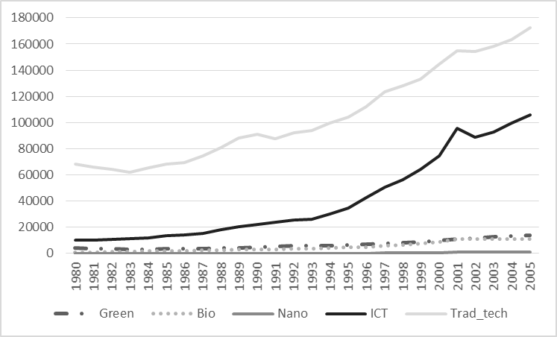 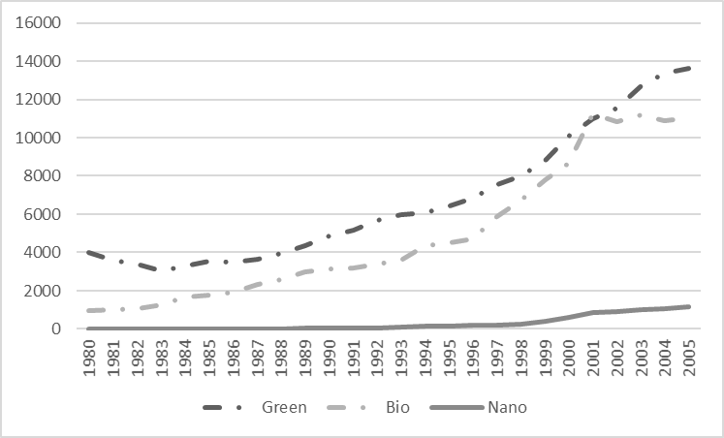

b) Share in total patents (in %)

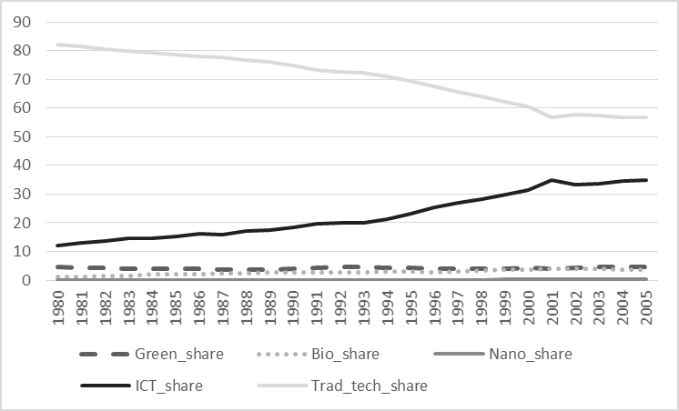 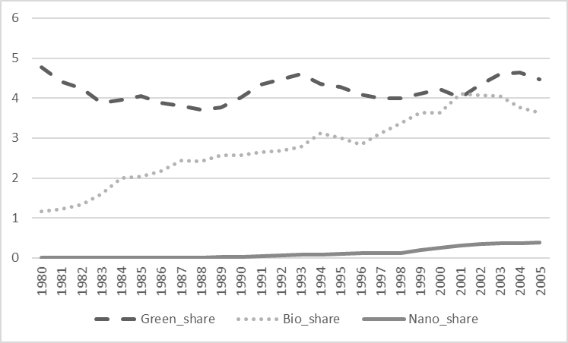

c) Number of citation-weighted patents

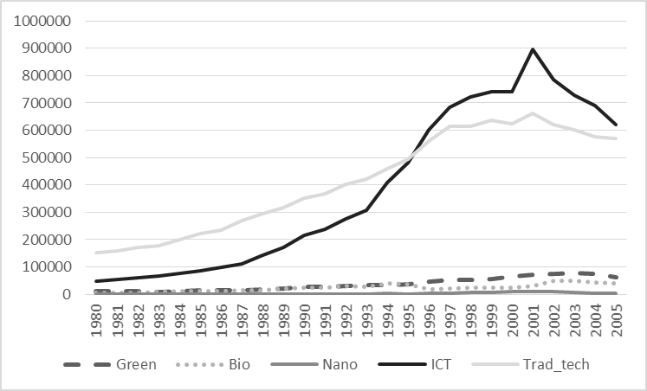 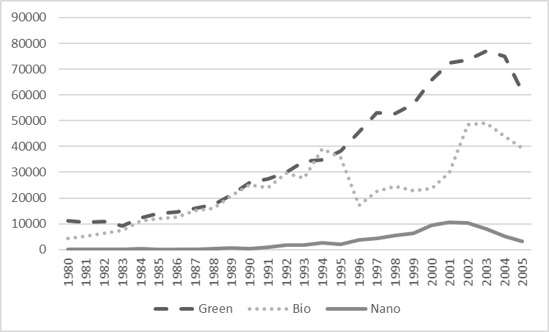

d) Share in total citation-weighted patents (in %)

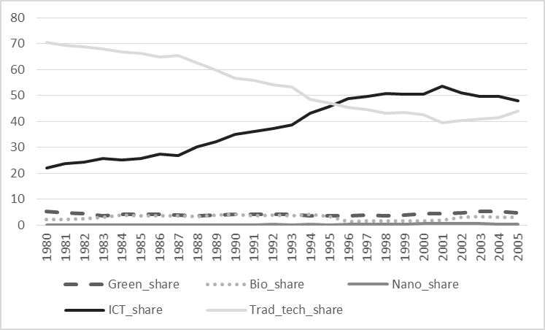 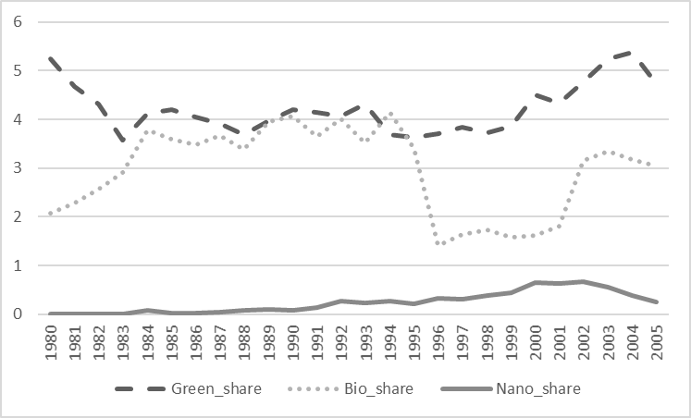

Note: The right Figures show the development for the technologies at the bottom line in the left Figures on a different scale (y-axis).

*Source:* Own calculations.

Table 1a: Number of a technology’s patents by country

|  |  |  |  |  |  |  |  |  |  |  |  |  |  |  |  |
| --- | --- | --- | --- | --- | --- | --- | --- | --- | --- | --- | --- | --- | --- | --- | --- |
|  | Green | | | Bio | | | Nano | | | ICT | | | Traditional technologies | | |
|  | Total number of patents | Relative share in  the country's total patents | Relative share in  the technology's total patents | Total number of patents | Relative share in  the country's total patents | Relative share in  the technology's total patents | Total number of patents | Relative share in  the country's total patents | Relative share in  the technology's total patents | Total number of patents | Relative share in  the country's total patents | Relative share in  the technology's total patents | Total number of patents | Relative share in  the country's total patents | Relative share in  the technology's total patents |
| DNK | 1594 | 5,28% | 0,81% | 2711 | 8,98% | 1,73% | 44 | 0,15% | 0,64% | 2951 | 9,78% | 0,28% | 22973 | 76,13% | 0,66% |
| FIN | 1424 | 3,30% | 0,73% | 1174 | 2,72% | 0,75% | 48 | 0,11% | 0,70% | 11183 | 25,89% | 1,08% | 29407 | 68,07% | 0,84% |
| GBR | 8879 | 3,44% | 4,53% | 12760 | 4,95% | 8,14% | 216 | 0,08% | 3,15% | 43617 | 16,90% | 4,21% | 192747 | 74,70% | 5,51% |
| GER | 61205 | 5,51% | 31,22% | 21679 | 1,95% | 13,84% | 1415 | 0,13% | 20,66% | 118891 | 10,70% | 11,47% | 908678 | 81,82% | 25,99% |
| ITA | 3779 | 3,38% | 1,93% | 2639 | 2,36% | 1,68% | 93 | 0,08% | 1,36% | 10086 | 9,02% | 0,97% | 95298 | 85,21% | 2,73% |
| JPN | 47201 | 4,66% | 24,08% | 21506 | 2,12% | 13,72% | 1483 | 0,15% | 21,65% | 311774 | 30,80% | 30,09% | 631806 | 62,41% | 18,07% |
| NLD | 4589 | 4,05% | 2,34% | 3863 | 3,41% | 2,47% | 115 | 0,10% | 1,68% | 27350 | 24,14% | 2,64% | 77512 | 68,43% | 2,22% |
| PRT | 117 | 5,06% | 0,06% | 182 | 7,88% | 0,12% | 2 | 0,09% | 0,03% | 349 | 15,10% | 0,03% | 1668 | 72,18% | 0,05% |
| SWE | 2933 | 3,89% | 1,50% | 2899 | 3,85% | 1,85% | 126 | 0,17% | 1,84% | 11882 | 15,77% | 1,15% | 57572 | 76,42% | 1,65% |
| USA | 64334 | 3,02% | 32,81% | 87281 | 4,10% | 55,70% | 3307 | 0,16% | 48,28% | 498216 | 23,40% | 48,08% | 1478010 | 69,42% | 42,28% |
| **Total** | **196055** | **4,01%** | **100,00%** | **156694** | **3,21%** | **100,00%** | **6849** | **0,14%** | **100,00%** | **1036299** | **21,21%** | **100,00%** | **3495671** | **71,54%** | **100,00%** |

Table 1b: Number of a technology’s patents by industry

|  |  |  |  |  |  |  |  |  |  |  |  |  |  |  |  |
| --- | --- | --- | --- | --- | --- | --- | --- | --- | --- | --- | --- | --- | --- | --- | --- |
|  | Green | | | Bio | | | Nano | | | ICT | | | Traditional technologies | | |
|  | Total number of patents | Relative share in  the industry's total patents | Relative share in  the technology's total patents | Total number of patents | Relative share in  the industry's total patents | Relative share in  the technology's total patents | Total number of patents | Relative share in  the industry's total patents | Relative share in  the technology's total patents | Total number of patents | Relative share in  the industry's total patents | Relative share in  the technology's total patents | Total number of patents | Relative share in  the industry's total patents | Relative share in  the technology's total patents |
| chemicals | 43413 | 6,31% | 22,14% | 113681 | 16,51% | 72,55% | 0 | 0,00% | 0,00% | 0 | 0,00% | 0,00% | 532398 | 77,33% | 15,23% |
| electrical equipment | 23369 | 1,22% | 11,92% | 43013 | 2,25% | 27,45% | 5208 | 0,27% | 76,04% | 1036299 | 54,29% | 100,00% | 805053 | 42,18% | 23,03% |
| food | 636 | 1,09% | 0,32% | 0 | 0,00% | 0,00% | 0 | 0,00% | 0,00% | 0 | 0,00% | 0,00% | 57664 | 98,91% | 1,65% |
| machinery | 41140 | 4,18% | 20,98% | 0 | 0,00% | 0,00% | 0 | 0,00% | 0,00% | 0 | 0,00% | 0,00% | 942598 | 95,82% | 26,96% |
| metals | 15529 | 5,95% | 7,92% | 0 | 0,00% | 0,00% | 1641 | 0,63% | 23,96% | 0 | 0,00% | 0,00% | 244027 | 93,43% | 6,98% |
| non-metallic minerals | 3704 | 2,54% | 1,89% | 0 | 0,00% | 0,00% | 0 | 0,00% | 0,00% | 0 | 0,00% | 0,00% | 142243 | 97,46% | 4,07% |
| other manufacturing | 71 | 0,05% | 0,04% | 0 | 0,00% | 0,00% | 0 | 0,00% | 0,00% | 0 | 0,00% | 0,00% | 142369 | 99,95% | 4,07% |
| paper | 144 | 0,36% | 0,07% | 0 | 0,00% | 0,00% | 0 | 0,00% | 0,00% | 0 | 0,00% | 0,00% | 39849 | 99,64% | 1,14% |
| rubber/plastics | 3135 | 1,54% | 1,60% | 0 | 0,00% | 0,00% | 0 | 0,00% | 0,00% | 0 | 0,00% | 0,00% | 200796 | 98,46% | 5,74% |
| textiles | 73 | 0,17% | 0,04% | 0 | 0,00% | 0,00% | 0 | 0,00% | 0,00% | 0 | 0,00% | 0,00% | 43199 | 99,83% | 1,24% |
| transport | 64810 | 16,28% | 33,06% | 0 | 0,00% | 0,00% | 0 | 0,00% | 0,00% | 0 | 0,00% | 0,00% | 333356 | 83,72% | 9,54% |
| wood | 31 | 0,26% | 0,02% | 0 | 0,00% | 0,00% | 0 | 0,00% | 0,00% | 0 | 0,00% | 0,00% | 12119 | 99,74% | 0,35% |
| **Total** | **196055** | **4,01%** | **100,00%** | **156694** | **3,21%** | **100,00%** | **6849** | **0,14%** | **100,00%** | **1036299** | **21,21%** | **100,00%** | **3495671** | **71,54%** | **100,00%** |

*Notes:* Data is based on own calculations; these statistics are based on 26 cross-sections, 10 countries and 12 industries (total of 3,120 observations).

Table 2:Variable definition and measurement

|  |  |  |  |  |  |  |
| --- | --- | --- | --- | --- | --- | --- |
|  | Definition/measurement | Source | Mean | Std. Dev. | Min | Max |
| Yijt | Value added measured in constant prices, million euros | Eberhardt et al. (2013) | 28227.04 | 53370.12 | 305.8684 | 782206.3 |
| Lijt | Labor, million hours worked | Eberhardt et al. (2013) | 914.8952 | 1217.501 | 14.645 | 6611.911 |
| Kijt | Physical capital, million euros | Eberhardt et al. (2013) | 41102.04 | 65200.85 | 299.1176 | 459870.4 |
| R&D_stockijt | R&D capital, million euros | Eberhardt et al. (2013) | 13454.34 | 40635.23 | .5581087 | 328953.4 |
| Patent_stockijt | Total stock of inventions | own calculations | 8720.242 | 25442.83 | .4437053 | 376030.9 |
| Traditional_stockijt | Stock of traditional inventions | own calculations | 6435.786 | 14986.72 | .4437053 | 129044.3 |
| New_growth_stockijt | Stock of inventions that are classified as green, ICT, nano or bio | own calculations | 2284.455 | 13391.18 | 0 | 246986.5 |
| Green_stockijt | Stock of green inventions | own calculations | 337.6636 | 968.9917 | 0 | 10019.97 |
| ICT_stockijt | Stock of ICT inventions | own calculations | 1691.473 | 12534.47 | 0 | 231626.8 |
| Nano_stockijt | Stock of nanotech inventions | own calculations | 8.749669 | 72.18582 | 0 | 1465.273 |
| Bio_stockijt | Stock of biotech inventions | own calculations | 255.3263 | 1518.699 | 0 | 28282.11 |

*Notes:* The descriptive statistics is based on the estimation sample of Table 5 (2,518 observations).

|  |  |  |  |  |  |  |  |  |  |  |
| --- | --- | --- | --- | --- | --- | --- | --- | --- | --- | --- |
|  | ∆ln(Yijt) | ∆ln(Lijt) | ∆ln(Kijt) | ∆ln(R&D_stockijt) | ∆ln(Patent_stockijt) | ∆ln(Traditional_stockijt) | ∆ln(New_growth_stockijt) | ∆ln(Green_stockijt) | ∆ln(ICT_stockijt) | ∆ln(Nano_stockijt) |
| ∆ln(Lijt) | 0.4799 |  |  |  |  |  |  |  |  |  |
| p-value | 0.0000 |  |  |  |  |  |  |  |  |  |
| ∆ln(Kijt) | 0.2643 | 0.4022 |  |  |  |  |  |  |  |  |
| p-value | 0.0000 | 0.0000 |  |  |  |  |  |  |  |  |
| ∆ln(R&D_stockijt) | 0.1076 | 0.0957 | 0.2245 |  |  |  |  |  |  |  |
| p-value | 0.0000 | 0.0000 | 0.0000 |  |  |  |  |  |  |  |
| ∆ln(Patent_stockijt) | 0.0427 | -0.0075 | 0.1382 | 0.1298 |  |  |  |  |  |  |
| p-value | 0.0323 | 0.7057 | 0.0000 | 0.0000 |  |  |  |  |  |  |
| ∆ln(Traditional_stockijt) | 0.0045 | -0.0208 | 0.0982 | 0.1221 | 0.9795 |  |  |  |  |  |
| p-value | 0.8224 | 0.2964 | 0.0000 | 0.0000 | 0.0000 |  |  |  |  |  |
| ∆ln(New_growth_stockijt) | 0.0604 | -0.0052 | 0.0544 | 0.0214 | 0.1566 | 0.0734 |  |  |  |  |
| p-value | 0.0024 | 0.7941 | 0.0063 | 0.2827 | 0.0000 | 0.0002 |  |  |  |  |
| ∆ln(Green_stockijt) | 0.0257 | -0.0228 | 0.0161 | 0.0069 | 0.1199 | 0.0579 | 0.9515 |  |  |  |
| p-value | 0.1969 | 0.2531 | 0.4204 | 0.7306 | 0.0000 | 0.0037 | 0.0000 |  |  |  |
| ∆ln(ICT_stockijt) | 0.2263 | 0.0651 | 0.2650 | 0.0712 | 0.2064 | 0.0668 | 0.1782 | 0.0488 |  |  |
| p-value | 0.0000 | 0.0011 | 0.0000 | 0.0003 | 0.0000 | 0.0008 | 0.0000 | 0.0144 |  |  |
| ∆ln(Nano_stockijt) | 0.1138 | 0.0623 | 0.1077 | -0.0429 | 0.0360 | -0.0153 | 0.0600 | 0.0115 | 0.3425 |  |
| p-value | 0.0000 | 0.0018 | 0.0000 | 0.0312 | 0.0709 | 0.4443 | 0.0026 | 0.5625 | 0.0000 |  |
| ∆ln(Bio_stockijt) | 0.1764 | 0.0463 | 0.1706 | 0.0799 | 0.1344 | 0.0462 | 0.1646 | 0.0638 | 0.4701 | 0.1757 |
| p-value | 0.0000 | 0.0200 | 0.0000 | 0.0001 | 0.0000 | 0.0203 | 0.0000 | 0.0014 | 0.0000 | 0.0000 |

Table 3: correlation matrix (based on the estimation sample of Table 5; 2,518 observations)

Table 4: Model selection; compare different estimators

|  |  |  |  |  |
| --- | --- | --- | --- | --- |
| Estimator: | Static first difference estimator | Static fixed effects estimator | Dynamic fixed effects estimator | Dynamic system GMM estimator |
|  | ∆ln(Yijt) | ln(Yijt) | ln(Yijt) | ln(Yijt) |
|  | (1) | (2) | (3) | (4) |
| ∆ln(Lijt) | 0.635*** |  |  |  |
|  | (16.011) |  |  |  |
| ln(Lijt) |  | 0.608*** | 0.651*** | 1.122 |
|  |  | (5.322) | (15.886) | (1.542) |
| ∆ln(Kijt) | 0.286*** |  |  |  |
|  | (2.707) |  |  |  |
| ln(Kijt) |  | 0.411*** | -0.155 | -0.155 |
|  |  | (2.861) | (-0.237) | (-0.208) |
| ∆ln(Traditional_stockijt) | -0.002 |  |  |  |
|  | (-0.111) |  |  |  |
| ln(Traditional_stockijt) |  | -0.036 | -0.003 | -0.058 |
|  |  | (-0.644) | (-0.128) | (-0.262) |
| ∆ln(New_growth_stockijt) | 0.035*** |  |  |  |
|  | (3.439) |  |  |  |
| ln(New_growth_stockijt) |  | 0.152*** | 0.018** | 0.359* |
|  |  | (3.317) | (2.470) | (2.048) |
| Year dummies | yes | yes | yes | yes |
| Industry-country fixed effects | no | yes | yes | no |
| Lagged dependent variable | no | no | yes | yes |
| Lagged independent variables | no | no | yes | yes |
| N | 2518 | 2637 | 2518 | 2518 |
| CD Test (p-value) | 0.165 | 0.006 | 0.089 | 0.117 |
| Non-stationarity of residuals: |  |  |  |  |
| Maddala and Wu (1999) | no | yes | no | no |
| Pesaran (2007) | no | yes | yes | yes |
| Sargan test of overid. restrictions (p-value) |  |  |  | 0.000 |
| Validity test of common factor restriction (p-value) |  |  | 0.727 | 0.034 |

*Notes:* see Table 3 for the variable definitions; t values based on standard errors that are robust to heteroskedasticity and clustered at the industry-country level (clustered sandwich estimator) are in brackets under the coefficients; ***, **, * denotes statistical significance at the 1%, 5% and 10% test level, respectively; CD Test: Test for H0 of cross-sectionally independent residuals (based on STATA *xtcd* command); Test on non-stationarity of residuals is based on user-written STATA *multipurt* command by Markus Eberhardt (see Eberhardt 2012); Sargan test: H0 not robust, but not weakened by many instruments; Test of common factor restriction: H0 valid common factor restriction; to increase comparability, we present long-run coefficients for the dynamic models (calculated in STATA based on user-written *md_ar1* command by Måns Söderbom (available through the authors’ personal web page) if common factor restriction is valid (column 3) and based on *nlcom* command if common factor restriction is not valid (column 4)); GMM: we collapsed the instrument sets (number of instruments 145), Hansen test: P= 0.826.

Table 5: OLS estimates of the determinants of change in value added

|  |  |  |  |  |  |  |  |  |
| --- | --- | --- | --- | --- | --- | --- | --- | --- |
|  | ∆ln(Yijt) | | | | | | | |
|  | (1) | (2) | (3) | (4) | (5) | (6) | (7) | (8) |
| ∆ln(Lijt) | 0.634*** | 0.641*** | 0.633*** | 0.635*** | 0.643*** | 0.648*** | 0.648*** | 0.647*** |
|  | (16.297) | (15.962) | (15.803) | (16.011) | (16.597) | (17.279) | (17.173) | (17.245) |
| ∆ln(Kijt) | 0.274*** | 0.283*** | 0.298*** | 0.286*** | 0.237** | 0.157* | 0.156* | 0.158* |
|  | (2.905) | (2.703) | (2.792) | (2.707) | (2.460) | (1.671) | (1.678) | (1.690) |
| ∆ln(R&D_stockijt) | 0.050 |  |  |  |  |  |  |  |
|  | (1.576) |  |  |  |  |  |  |  |
| ∆ln(Patent_stockijt) |  | 0.038 |  |  |  |  |  |  |
|  |  | (1.409) |  |  |  |  |  |  |
| ∆ln(Traditional_stockijt) |  |  | 0.005 | -0.002 | -0.009 | -0.008 | -0.007 | -0.007 |
|  |  |  | (0.250) | (-0.111) | (-0.464) | (-0.404) | (-0.359) | (-0.352) |
| ∆ln(New_growth_stockijt) |  |  |  | 0.035*** | -0.109*** |  |  |  |
|  |  |  |  | (3.439) | (-3.319) |  |  |  |
| ∆ln(Traditional_stockijt)*∆ln(New_growth_stockijt) |  |  |  |  | 0.022*** |  |  |  |
|  |  |  |  |  | (4.214) |  |  |  |
| ∆ln(Green_stockijt) |  |  |  |  |  | 0.017** |  |  |
|  |  |  |  |  |  | (2.191) |  |  |
| ∆ln(ICT_stockijt) |  |  |  |  |  | 0.248*** |  |  |
|  |  |  |  |  |  | (3.563) |  |  |
| ∆ln(Nano_stockijt) |  |  |  |  |  | 0.012 |  |  |
|  |  |  |  |  |  | (0.976) |  |  |
| ∆ln(Bio_stockijt) |  |  |  |  |  | 0.095*** |  |  |
|  |  |  |  |  |  | (3.100) |  |  |
| ∆ln(Only_green_stockijt) |  |  |  |  |  |  | 0.013 | 0.012 |
|  |  |  |  |  |  |  | (1.633) | (1.528) |
| ∆ln(Only_ICT_stockijt) |  |  |  |  |  |  | 0.227*** | 0.246*** |
|  |  |  |  |  |  |  | (3.791) | (3.586) |
| ∆ln(Only_nano_stockijt) |  |  |  |  |  |  | 0.009 | 0.012 |
|  |  |  |  |  |  |  | (0.834) | (0.979) |
| ∆ln(Only_bio_stockijt) |  |  |  |  |  |  | 0.072** | 0.093*** |
|  |  |  |  |  |  |  | (2.510) | (3.070) |
| ∆ln(Bio_green_stockijt) |  |  |  |  |  |  | 0.036** |  |
|  |  |  |  |  |  |  | (2.576) |  |
| ∆ln(Nano_green_stockijt) |  |  |  |  |  |  | 0.025 |  |
|  |  |  |  |  |  |  | (0.815) |  |
| ∆ln(ICT_green_stockijt) |  |  |  |  |  |  | 0.062 |  |
|  |  |  |  |  |  |  | (1.468) |  |
| Year Dummies | yes | yes | yes | yes | yes | yes | yes | yes |
| N | 2518 | 2518 | 2518 | 2518 | 2518 | 2518 | 2518 | 2518 |
| F | 47.33*** | 48.54*** | 46.86*** | 46.80*** | 47.09*** | 50.00*** | 45.22*** | 49.72*** |
| r2 | 0.33 | 0.33 | 0.32 | 0.33 | 0.34 | 0.36 | 0.36 | 0.36 |
| CD Test (p-value) | 0.208 | 0.186 | 0.248 | 0.165 | 0.164 | 0.229 | 0.236 | 0.165 |
| Non-stationarity of residuals: |  |  |  |  |  |  |  |  |
| Maddala and Wu (1999) | no | no | no | no | no | no | no | no |
| Pesaran (2007) | no | no | yes | no | no | no | no | no |

*Notes:* see Table 3 for the variable definitions; t values based on standard errors that are robust to heteroskedasticity and clustered at the industry-country level (clustered sandwich estimator) are in brackets under the coefficients; ***, **, * denotes statistical significance at the 1%, 5% and 10% test level, respectively.

Figure 2: Patents by technology based on excluding categories

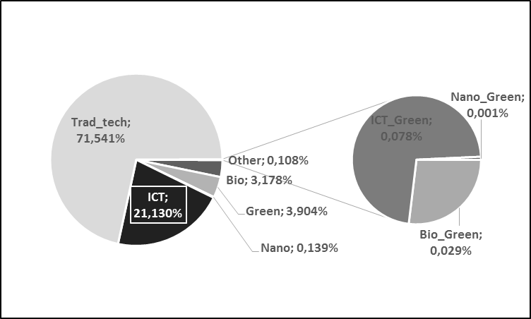

*Source:* Own calculations.

APPENDIX

Appendix 1: A note on the construction of the knowledge variables

Knowledge in new growth technologies is identified using the International Patent Classification (IPC) system. We chose between OECD definitions and WIPO definitions and selected the one with the broadest coverage.

*Identification of patents in Information and Communication Technologies (ICT) (WIPO 2013):*

Patents taken in the ICT sector can be split into four fields, based on the following list of IPC codes:

* Audio-visual technology:

G09F, G09G, G11B, H04N, H04R, H04S, H05K

* Telecommunications

G08C, H01P, H01Q, H04B, H04H, H04J, H04K, H04M, H04N(1%), H04Q%

* Digital communication

H04L, H04N(21%), H04W

* Basic communication processes:

H03B, H03C, H03D, H03F, H03G, H03H, H03J, H03K, H03L, H03M

* Computer technology:

G06C, G06D, G06E, G06F, G06G, G06J, G06K, G06M, G06N, G06T, G10L, G11C

* IT methods for management

G06Q

* Semiconductors

H01L

*Identification of patents in biotechnology (OECD 2008):*

A01H1/00, A01H4/00, A61K38/00, A61K39/00, A61K48/00,

C02F3/34, C07G(11/00,13/00,15/00), C07K(4/00,14/00,16/00,17/00,19/00), C12M, C12N, C12P, C12Q, C12S,G01N27/327, G01N33/(53*,54*,55*,57*,68,74,76,78,88,92)].

*Identification of patents in nanotechnology (WIPO 2013):*

B81B, B81C, B82B, B82Y

*Identification of patents in green technologies (OECD 2011):*

Patents taken in the green sector can be split into seven technological fields, based on the following list of IPC codes:

* General environmental management

B01D46, B01D47, B01D49, B01D50, B01D51, B01D53/34-72, B03C3, C10L10/02, C10L10/06, C21B7/22, C21C5/38, F01N3, F01N5, F01N7, F01N9, F23B80, F23C9, F23G7/06, F23J15, F27B1/18, B63J4, C02F, C05F7, C09K3/32, E02B15/04-06, E02B15/10, E03B3, E03C1/12, E03F, E01H15, B65F, A23K1/06-10, A43B1/12, A43B21/14, B03B9/06, B22F8, B29B7/66, B29B1, B30B9/32, B62D67, B65H73, B65D65/46, C03B1/02, C03C6/02, C03C6/08, C04B7/24-30, C04B11/26, C04B18/04-10, C04B33/132, C08J11, C09K11/01, C10M175, C22B7, C22B19/28-30, C22B25/06, D01G11, D21B1/08-10, D21B1/32 , D21C5/02, D21H17/01, H01B 15/00, H01J 9/52, H01M 6/52, H01M 10/54, C05F1, C05F5, C05F7, C05F9, C05F17, C10L5/46-48, F23G5, F23G7, B09B, C10G1/10, A61L11, F01N11, G08B21/12-14,

* Energy generation from renewable and non-fossil sources

Y02E10/7*, Y02E10/4*, Y02E10/5*, Y02E10/6*, Y02E10/1*, Y02E10/3*, Y02E10/28, Y02E10/22B, Y02E10/22BD, Y02E50/1*, Y02E50/3*

* Cumbustion technologies with mitigation potential (e.g. using fossil fuels, biomass, waste)

Y02E20/1*, Y02E20/3*

* Technologies specific to climate change mitigation

Y02C10/*, Y02C20/*

* Technologies with potential or indirect contribution to emissions mitigation

Y02E60/1*, Y02E60/3*, Y02E60/5*

* Emissions abatement and fuel efficiency in transportation

F02B47/06, F02M3/02-055, F02M23, F02M25, F02M67, F01N9, F02D41, F02D43, F02D45, F01N11, G01M15/10, F02M39-71, F02P5, F02M27, F02M31/02-18, F01M13/02-04, F01N5, F02B47/08-10, F02D21/06-10, F02M25/07, F01N11, G01M15/10, F01N3/26, B01D53/92, B01D53/94, B01D53/96, B01J23/38-46, F01N3/05, F01N3/08-34, B60K1, B60L7/10-20, B60L11, B60L15, B60R16/033, B60R16/04, B60S5/06, B60W10/08, B60W10/26, B60W10/28, B60K16, B60L8, B60K6, B60W20, B62D 35/00, B62D 37/02, B60C 23/00, B60T 1/10, B60G 13/14, B60K 31/00, B60W 30/10-20

* Energy efficiency in buildings and lighting

E04B1/62, E04B1/74-78, E04B1/88, E06B3/66-677, E06B3/24, F24D3/08, F24D3/18, F24D5/12, F24D11/02, F24D15/04, F24D17/02, F24F12, F25B29, F25B30, H01J61, H05B33

Appendix 2: Example of assignments of patents to industries and new growth technologies for patent MX2016009194

**Sector (NACE):**

Electrical equipment: G06C, H02J

Transport: B62D

*Note:* This patent has been assigned to the IPCs B62D33/027, G06C7/02, and H02J7/00, which are allocated to the transport and the electrical equipment industry, respectively. This allocation is based on the concordance table of Schmoch et al. (2003). Moreover, we know from the definition of new growth technologies (see Appendix 1) that the IPC G06C is assigned to ICT and the other IPCs are not assigned to any other new growth technology. Hence, this patent counts as a traditional patent for the transport industry and as an ICT patent for the electrical equipment industry.



Table A.1: Test the effect of single new growth technologies separately

|  |  |  |  |  |
| --- | --- | --- | --- | --- |
|  | ∆ln(Yijt) | | | |
|  | (1) | (2) | (3) | (4) |
| ∆ln(Lijt) | 0.642*** | 0.647*** | 0.637*** | 0.647*** |
|  | (16.063) | (16.948) | (15.920) | (16.900) |
| ∆ln(Kijt) | 0.280*** | 0.169* | 0.265*** | 0.223** |
|  | (2.682) | (1.791) | (2.668) | (2.299) |
| ∆ln(Non_green_stockijt) | 0.033 |  |  |  |
|  | (1.292) |  |  |  |
| ∆ln(Green_stockijt) | 0.021*** |  |  |  |
|  | (2.790) |  |  |  |
| ∆ln(Non_ICT_stockijt) |  | -0.000 |  |  |
|  |  | (-0.019) |  |  |
| ∆ln(ICT_stockijt) |  | 0.318*** |  |  |
|  |  | (4.596) |  |  |
| ∆ln(Non_nano_stockijt) |  |  | 0.037 |  |
|  |  |  | (1.381) |  |
| ∆ln(Nano_stockijt) |  |  | 0.046** |  |
|  |  |  | (2.495) |  |
| ∆ln(Non_bio_stockijt) |  |  |  | 0.023 |
|  |  |  |  | (0.954) |
| ∆ln(Bio_stockijt) |  |  |  | 0.184*** |
|  |  |  |  | (5.145) |
| Year Dummies | yes | yes | yes | yes |
| N | 2518 | 2518 | 2518 | 2518 |
| F | 46.81*** | 49.70*** | 48.25*** | 51.33*** |
| r2 | 0.33 | 0.36 | 0.33 | 0.34 |

*Notes:* see Table 3 for the variable definitions; t values based on standard errors that are robust to heteroskedasticity and clustered at the industry-country level (clustered sandwich estimator) are in brackets under the coefficients; ***, **, *, † denotes statistical significance at the 1%, 5%, 10% and 15% test level, respectively.

Table A.2: Test linearity of the knowledge effects and the effect of knowledge availability

|  |  |  |  |  |
| --- | --- | --- | --- | --- |
|  | ∆ln(Yijt) | | | |
|  | (1) | (2) | (3) | (4) |
| ∆ln(Lijt) | 0.647*** | 0.650*** | 0.644*** | 0.648*** |
|  | (16.307) | (17.003) | (16.155) | (16.959) |
| ∆ln(Kijt) | 0.255** | 0.162* | 0.267*** | 0.227** |
|  | (2.495) | (1.749) | (2.697) | (2.335) |
| ∆ln(Non_green_stockijt) | 0.033 |  |  |  |
|  | (1.293) |  |  |  |
| ∆ln(Green_stock_dijt) | 0.021 |  |  |  |
|  | (1.231) |  |  |  |
| ∆ln(Green_stockijt) | -0.028* |  |  |  |
|  | (-1.736) |  |  |  |
| ∆ln(Green_stockijt)*∆ln(Green_stockijt) | 0.013*** |  |  |  |
|  | (3.615) |  |  |  |
| ∆ln(Non_ICT_stockijt) |  | 0.006 |  |  |
|  |  | (0.278) |  |  |
| ∆ln(ICT_stock_dijt) |  | 0.000 |  |  |
|  |  | N/A |  |  |
| ∆ln(ICT_stockijt) |  | -0.018 |  |  |
|  |  | (-0.174) |  |  |
| ∆ln(ICT_stockijt)*∆ln(ICT_stockijt) |  | 0.025** |  |  |
|  |  | (2.499) |  |  |
| ∆ln(Non_nano_stockijt) |  |  | 0.037 |  |
|  |  |  | (1.389) |  |
| ∆ln(Nano_stock_dijt) |  |  | 0.025 |  |
|  |  |  | (1.121) |  |
| ∆ln(Nano_stockijt) |  |  | -0.014 |  |
|  |  |  | (-0.410) |  |
| ∆ln(Nano_stockijt)*∆ln(Nano_stockijt) |  |  | 0.014* |  |
|  |  |  | (1.862) |  |
| ∆ln(Non_bio_stockijt) |  |  |  | 0.030 |
|  |  |  |  | (1.213) |
| ∆ln(Bio_stock_dijt) |  |  |  | N/A |
|  |  |  |  |  |
| ∆ln(Bio_stockijt) |  |  |  | -0.007 |
|  |  |  |  | (-0.071) |
| ∆ln(Bio_stockijt)*∆ln(Bio_stockijt) |  |  |  | 0.019* |
|  |  |  |  | (1.789) |
| Year Dummies | yes | yes | yes | yes |
| N | 2518 | 2518 | 2518 | 2518 |
| F | 44.50*** | 51.13*** | 43.46*** | 48.65*** |
| r2 | 0.33 | 0.36 | 0.33 | 0.35 |

*Notes:* see Table 3 for the variable definitions; t values based on standard errors that are robust to heteroskedasticity and clustered at the industry-country level (clustered sandwich estimator) are in brackets under the coefficients; ***, **, *, † denotes statistical significance at the 1%, 5%, 10% and 15% test level, respectively; as we do not observe industries that start innovating in biotechnologies or ICT in our estimation period, the effects of ICT_stock_d and Bio_stock_d cannot be identified.

Table A.3: Test complementarity with traditional knowledge

|  |  |  |  |  |
| --- | --- | --- | --- | --- |
|  | ∆ln(Yijt) | | | |
|  | (1) | (2) | (3) | (4) |
| ∆ln(Lijt) | 0.648*** | 0.651*** | 0.646*** | 0.651*** |
|  | (16.472) | (16.970) | (16.251) | (17.222) |
| ∆ln(Kijt) | 0.243** | 0.164* | 0.260*** | 0.196** |
|  | (2.495) | (1.763) | (2.682) | (2.106) |
| ∆ln(Non_green_stockijt) | 0.024 |  |  |  |
|  | (0.966) |  |  |  |
| ∆ln(Green_stockijt) | -0.101*** |  |  |  |
|  | (-3.101) |  |  |  |
| ∆ln(Non_green_stockijt)*∆ln(Green_stockijt) | 0.019*** |  |  |  |
|  | (3.863) |  |  |  |
| ∆ln(Non_ICT_stockijt) |  | 0.002 |  |  |
|  |  | (0.090) |  |  |
| ∆ln(ICT_stockijt) |  | 0.070 |  |  |
|  |  | (0.601) |  |  |
| ∆ln(Non_ICT_stockijt)*∆ln(ICT_stockijt) |  | 0.023* |  |  |
|  |  | (1.812) |  |  |
| ∆ln(Non_nano_stockijt) |  |  | 0.037 |  |
|  |  |  | (1.406) |  |
| ∆ln(Nano_stockijt) |  |  | -0.185** |  |
|  |  |  | (-2.613) |  |
| ∆ln(Non_nano_stockijt)*∆ln(Nano_stockijt) |  |  | 0.026*** |  |
|  |  |  | (3.151) |  |
| ∆ln(Non_bio_stockijt) |  |  |  | 0.023 |
|  |  |  |  | (0.966) |
| ∆ln(Bio_stockijt) |  |  |  | -0.287*** |
|  |  |  |  | (-2.984) |
| ∆ln(Non_bio_stockijt)*∆ln(Bio_stockijt) |  |  |  | 0.046*** |
|  |  |  |  | (4.257) |
| Year Dummies | yes | yes | yes | yes |
| N | 2518 | 2518 | 2518 | 2518 |
| F | 46.69*** | 48.84*** | 47.73*** | 44.42*** |
| r2 | 0.34 | 0.36 | 0.34 | 0.36 |

*Notes:* see Table 3 for the variable definitions; t values based on standard errors that are robust to heteroskedasticity and clustered at the industry-country level (clustered sandwich estimator) are in brackets under the coefficients; ***, **, *, † denotes statistical significance at the 1%, 5%, 10% and 15% test level, respectively.

Table A.4: Use citation-weighted patent stocks (same models as in Table 5)

|  |  |  |  |  |  |  |  |
| --- | --- | --- | --- | --- | --- | --- | --- |
|  | ∆ln(Yijt) | | | | | | |
|  | (1) | (2) | (3) | (4) | (5) | (6) | (7) |
| ∆ln(Lijt) | 0.635*** | 0.632*** | 0.632*** | 0.632*** | 0.639*** | 0.638*** | 0.639*** |
|  | (16.154) | (16.146) | (16.078) | (16.552) | (16.966) | (16.916) | (16.978) |
| ∆ln(Kijt) | 0.294*** | 0.301*** | 0.299*** | 0.271*** | 0.193** | 0.185* | 0.195** |
|  | (2.775) | (2.821) | (2.814) | (2.749) | (2.031) | (1.980) | (2.048) |
| ∆ln(Patent_stockijt) | 0.009 |  |  |  |  |  |  |
|  | (0.729) |  |  |  |  |  |  |
| ∆ln(Traditional_stockijt) |  | -0.001 | -0.002 | -0.006 | -0.004 | -0.004 | -0.005 |
|  |  | (-0.088) | (-0.189) | (-0.542) | (-0.441) | (-0.366) | (-0.449) |
| ∆ln(New_growth_stockijt) |  |  | 0.009** | -0.065*** |  |  |  |
|  |  |  | (2.269) | (-2.746) |  |  |  |
| ∆ln(Traditional_stockijt)*∆ln(New_growth_stockijt) |  |  |  | 0.010*** |  |  |  |
|  |  |  |  | (3.109) |  |  |  |
| ∆ln(Green_stockijt) |  |  |  |  | 0.006† |  |  |
|  |  |  |  |  | (1.506) |  |  |
| ∆ln(ICT_stockijt) |  |  |  |  | 0.191*** |  |  |
|  |  |  |  |  | (3.706) |  |  |
| ∆ln(Nano_stockijt) |  |  |  |  | 0.006† |  |  |
|  |  |  |  |  | (1.572) |  |  |
| ∆ln(Bio_stockijt) |  |  |  |  | 0.061*** |  |  |
|  |  |  |  |  | (2.868) |  |  |
| ∆ln(Only_green_stockijt) |  |  |  |  |  | 0.002 | 0.001 |
|  |  |  |  |  |  | (0.424) | (0.392) |
| ∆ln(Only_ICT_stockijt) |  |  |  |  |  | 0.175*** | 0.188*** |
|  |  |  |  |  |  | (3.476) | (3.649) |
| ∆ln(Only_nano_stockijt) |  |  |  |  |  | 0.006* | 0.006* |
|  |  |  |  |  |  | (1.679) | (1.672) |
| ∆ln(Only_bio_stockijt) |  |  |  |  |  | 0.058*** | 0.060*** |
|  |  |  |  |  |  | (2.626) | (2.868) |
| ∆ln(Bio_green_stockijt) |  |  |  |  |  | 0.011 |  |
|  |  |  |  |  |  | (1.170) |  |
| ∆ln(Nano_green_stockijt) |  |  |  |  |  | 0.001 |  |
|  |  |  |  |  |  | (0.108) |  |
| ∆ln(ICT_green_stockijt) |  |  |  |  |  | 0.028† |  |
|  |  |  |  |  |  | (1.656) |  |
| Year Dummies | yes | yes | yes | yes | yes | yes | yes |
| N | 2518 | 2518 | 2518 | 2518 | 2518 | 2518 | 2518 |
| F | 47.05*** | 45.81*** | 48.36*** | 48.57*** | 53.57*** | 50.89*** | 56.46*** |
| r2 | 0.32 | 0.32 | 0.33 | 0.34 | 0.35 | 0.35 | 0.35 |

*Notes:* see Table 3 for the variable definitions; t values based on standard errors that are robust to heteroskedasticity and clustered at the industry-country level (clustered sandwich estimator) are in brackets under the coefficients; ***, **, *, † denotes statistical significance at the 1%, 5%, 10% and 15% test level, respectively.

Table A.5: Results based on dynamic fixed effects estimator

|  |  |  |
| --- | --- | --- |
|  | ln(Yijt) | |
|  | (1) | (2) |
| ln(Lijt) | 0.667*** | 0.747*** |
|  | (15.367) | (4.576) |
| l.ln(Lijt) | -0.584*** |  |
|  | (-13.584) |  |
| ln(Kijt) | 0.042 | -0.075 |
|  | (0.484) | (-0.467) |
| l.ln(Kijt) | -0.050 |  |
|  | (-0.565) |  |
| ln(Traditional_stockijt) | -0.024 | -0.058 |
|  | (-0.941) | (-0.602) |
| l.ln(Traditional_stockijt) | 0.018 |  |
|  | (0.745) |  |
| ln(Green_stockijt) | 0.012† | 0.022 |
|  | (1.633) | (0.424) |
| l.ln(Green_stockijt) | -0.009 |  |
|  | (-1.091) |  |
| ln(ICT_stockijt) | -0.032 | 0.345*** |
|  | (-0.292) | (3.006) |
| l.ln(ICT_stockijt) | 0.070 |  |
|  | (0.623) |  |
| ln(Nano_stockijt) | -0.002 | 0.019 |
|  | (-0.135) | (0.431) |
| l.ln(Nano_stockijt) | 0.004 |  |
|  | (0.270) |  |
| ln(Bio_stockijt) | -0.059 | 0.072 |
|  | (-1.188) | (1.009) |
| l.ln(Bio_stockijt) | 0.067† |  |
|  | (1.482) |  |
| l.ln(Yijt) | 0.890*** |  |
|  | (28.862) |  |
| Year dummies | yes | yes |
| Industry-country fixed effects | yes | yes |
| Lagged dependent variable | yes | yes |
| Lagged independent variables | yes | yes |
| N | 2518 | |
| CD Test (p-value) | 0.085 | |
| Non-stationarity of residuals: |  |  |
| Maddala and Wu (1999) | yes | |
| Pesaran (2007) | yes | |

*Notes:* see Table 3 for the variable definitions; t values based on standard errors that are robust to heteroskedasticity and clustered at the industry-country level (clustered sandwich estimator) are in brackets under the coefficients; ***, **, *, † denotes statistical significance at the 1%, 5%, 10% and 15% test level, respectively; CD Test: Test for H0 of cross-sectionally independent residuals (based on STATA xtcd command); Test on non-stationarity of residuals is based on user-written STATA multipurt command by Markus Eberhardt (see Eberhardt 2012); long-run coefficients for the dynamic models are calculated in STATA using the nlcom command.

Figure A.1: Number of forward citations per patent (all sample countries; 1980-2005)

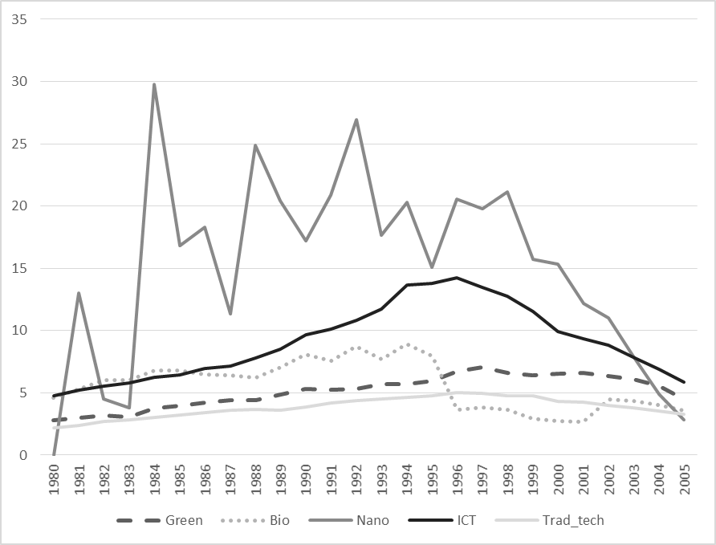

*Source:* Own calculations.

1. There are much more investigations comparing the innovation output in nanotechnologies across countries (Li et al. 2007), or the economic impact of the use of nano-products (Freeman 2003).
2. There are many studies that investigate the Porter hypotheses, however, this type of studies mainly looks at the economic returns of the adoption of environmentally friendly technologies (e.g., Lanoie et al. 2011, Stucki 2019) and not the creation of such technologies.
3. In contrast to their study, we have specific information on the industries’ technology-specific knowledge base as well as their global knowledge base, which allows us to analyze directly whether knowledge in new growth technologies is competence-enhancing or competence-destroying.
4. Aghion et al. (2016) and Stucki and Woerter (2017) find that traditional knowledge positively affects green innovation activities indicating complementarities between green and traditional knowledge. Rothaermel and Thursby (2007) analyze the relevance of R&D for the creation of nanotechnologies and biotechnologies. They show that R&D is an important driver for the creation of such technologies. However, as they do not differentiate between technology specific R&D and general R&D it remains unclear, whether the technologies are competence-enhancing or destroying.
5. Related to the studies by Aghion et al. (2016) and Stucki and Woerter (2017) for green technologies, we also made some basic regressions in which we tried to identify the effects of knowledge spillovers directly. However, the correlation between the different stocks of knowledge turned out to be too high to be able to identify the different effects. Hence, technology specific regressions would be required. This, however, would complicate the comparison of the effects across the different technologies, which actually is the main goal of this paper.
6. The industries are grouped as follows: food (SIC 15, 16), textiles (SIC 17, 18, 19), wood (SIC 20), paper (SIC 21, 22), chemicals (SIC 24), rubber/plastics (SIC 25), non-metallic minerals (SIC 26), metals (SIC 27, 28), machinery (SIC 29), electrical equipment (SIC 30, 31, 32, 33), transport (SIC 34, 35), other manufacturing (SIC 36, 37). SIC 23 (coke, refined petroleum products and nuclear fuels), for which several countries do not report data, is excluded.
7. The reason for excluding other countries are data restrictions (see Eberhardt et al. 2013). For France, for example, we do not have the same gross fixed capital formation (GFCF) available as for the other countries, which makes it difficult to argue that the capital stock is constructed analogously to the other countries. However, it is very unlikely that the results would change, if we include other countries, given that we control for country-industry fixed effects, and that we already consider many countries.
8. There is an update of the EU KLEMS database published end of 2017. However, we wanted to be as close as possible to the econometric procedure of Eberhardt et al. (2013) in order to avoid any discussion about data quality and its comparability across time (e.g. in terms of industry classification) and calculation of appropriate measures for value added, labor and capital stock, which is a highly controversial topic. Further investigations are required to test whether our findings hold for the last years as well. Patent data at least do not indicate that the technological trends of previous years have changed significantly since 2005.
9. An exception is the software industry. However, copyrights are more important than patents to protect intellectual property rights of software. It is thus hardly possible to identify such knowledge based using patent data.
10. If a patent has inventors in different countries, we assign the patent to every inventors’ country, since we assume that once the knowledge is created and patented it is available in all participating countries to its full extend and not only a fraction of it.
11. As an alternative to the static concordance scheme introduced in Schmoch et al. (2013), there are more recently developed, dynamic concordance tables by Lybbert and Zolas (2014), which uses a weighing scheme to assign patents to industries. However, on the course level of assignment in our study (2-digit industries) there are not significant differences (see Lybbert and Zolas 2014).
12. Note that the identification of new growth technologies and the assignment of patents to industries are two separate steps. In the first step, we use the Schmoch et al. (2003) concordance table to identify the industry-specific IPC information of the patents, which allows us to assign the patents to industries. In the second step, we then use the industry-specific IPC information to assign the patents to new growth technologies based on OECD and WIPO classifications. For more information see Appendix 2.
13. Similar to Eberhardt et al. (2013), we restricted our sample period to the years 1980-2005. However, we use patent applications between 1975 and 1980 in order to calculate pre-sample invention stocks. The initial value of the invention stock is set at *Green_stock*1975/(*δ*+*g*), where *g* is the pre-1975 growth in invention stock that is assumed to be 15%.
14. We estimated the main models with different depreciation rates, i.e. 5%, 10%, 20%, and 30%. The main results do not change (estimations available upon request).
15. In order to capture a potential bias, alternative estimations control for the effect of knowledge availability in a certain technology by including dummy variables that take the value 1 if an industry has knowledge in a certain technology and the value zero if not (see Table A.2 in the appendix).
16. In further estimates, we find that traditional (non-technology specific) knowledge does not significantly positively affect the creation of the considered new growth technologies (traditional knowledge even significantly negatively affects the creation of ICT and green technologies). Hence, complementarities on the commercial end and not on the R&D end seem to drive our results (estimation results are available on request).
17. Test results are as follows (p-values for test of equality): ICT vs. biotechnologies: p=0.071; biotechnologies vs. green technologies: p=0.019; biotechnologies vs. nanotechnologies: p=0.015; biotechnologies vs. traditional technologies: p=0.002; nanotechnologies vs. green technologies: p=0.705; nanotechnologies vs. traditional technologies: p=0.402; green technologies vs. traditional technologies: p=0.192.
18. Notice that we do not observe switches in biotechnology and ICT meaning that there have not been any industry starting this type of technological activity during our period of observation.
19. The turning-point is rather low; positive productivity effects can be expected with a change of more than three Green-stock units annually. Estimating the turning point: